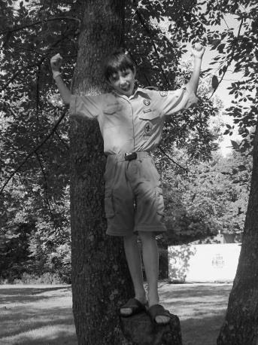What a Great, Great Summer…… Summer Camp, Day Camp, Venture Blast, National Jamboree
Prairielands Post, Page 5
THANK YOU to the entire Camp Drake Staff for a fantastic Summer camping season! Over 600 campers enjoyed summer camping adventures on the banks of the Salt Fork River in 2013! A special thank you goes out to Mike Graham (Camp Director), Carson Lewis (Program Director), Robert Sloan (Commissioner), and Brian Brauer (Assistant Camp Director) for their leadership and expertise and time in helping to create a fantastic summer camping experience for hundreds of Scouts and Scouters this summer!

Prairielands Council Cub Scout Day Camp

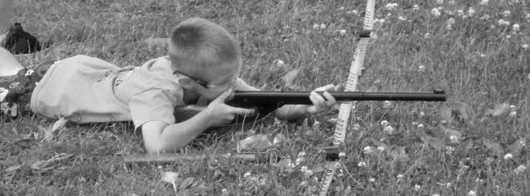The theme says it all….. we had over 250 Cub Scouts from all over the Council participate in this year Cub Day Camp program which was fun for everyone. We traveled back to medieval times and had the Scouts doing some awesome activities like making their own shield in our craft session, playing jousting, watching professional do Fencing from the Point, and of course some of the Scouts favorite activities like BB guns, Archery, Swimming, Sling Shots and much more! A HUGE THANK YOU to our Day Camp staff, Dakorie McElhaney, Brian Minsker, Todd Buhrmester, Linda Atherton, Jean Holmes, Dave Johnson, Rebecca Gatewood, Sara Rawlins, Larry VanDeVeer, Terry Harbin, our wonderful youth staff, and all the terrific PACK WALKERS!!! A special Thank YOU goes out to Jean Holmes of Pack 76 Atwood for being the Camp director for Tuscola Day Camp the last 4 years, you have done an AWESOME JOB and Prairielands Council sincerely appreciate your time, talent, energy and dedication to the program, you will be missed! Prairielands Council also wants to recognize and say THANK YOU to Council Day Camp Coordinator Brian Minsker who will be stepping down after eight wonderful years of keeping us all together, informed and on track! We appreciate your dedication and commitment to our youth program, YOU ROCK!!
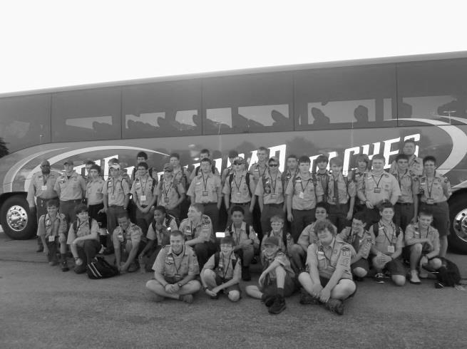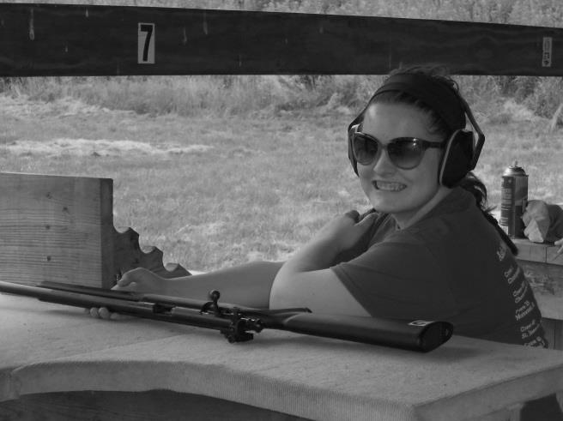
National Jamboree at Bechtel Summit Reserve
Venturing Summer Blast at Camp Drake

Prairielands Post, Page 6
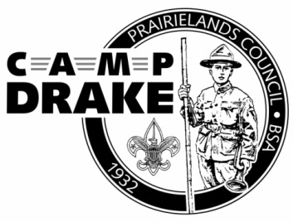
CAMP LAUNCH 2014
It’s never too early to start planning for 2014! The Camp Launch for the 2014 camping season will be held at 9:00 a.m. on Saturday, December 14 in Champaign. Location and timing information will be available in the Fall Prairielands Post, and at www.CampDrake.com. Reservations for 2014 Boy Scout Resident Camp can be made today by contacting Susan Coller at the Prairielands Council Scout Office at Susan.Coller@Scouting.org. See you at Drake in 2014!

Camp Drake Available Year-Round!
Did you know that Camp Drake is available on a year-round basis for unit camping? Campsites, group cabins (with wood-burning stoves), staff cabins, and Training Center facilities are available for rent throughout the year! Please contact Susan Coller at the Prairielands Council Scout Office at Susan.Coller@Scouting.org for more information or to secure your unit’s reservation! Summer may be drawing to a close, but the outdoor excitement never ends at Camp Drake!

Camping Committee Needs Your Help!
Are you interested in serving Camp Drake year-round? The Prairielands Council Program Committee needs your help! The Camping Program Committee oversees the operation of Camp Drake’s summer camp program, as well as all year-round programs out at Camp. Adult volunteers are needed to help advise and oversee program areas and events throughout the year. If you are interested in contributing your thoughts, ideas, and talents to the betterment of Camp Drake, please contact Camping Committee Chair John Marquardt at jrmarqua@illinois.edu. Opportunities are available in a variety of areas, skill sets, and time commitments!

Log-On and Connect with Camp Drake Year-Round!
Never miss out on Camp Drake breaking news and program information again! Connect with Camp Drake on Facebook (Camp Robert Drake) and follow Camp Drake on Twitter (@campdrakebsa) today! As always, www.CampDrake.com remains the premiere location for all critical Camp Drake leader updates, program information and registration, games, news bulletins, training opportunities, and more!

Tread Lightly Trainer’s Class September 15 @ Camp Drake
Become a Tread Lightly Trainer to run workshops teaching low-impact activities including the use of motorized vehicles.
The class is ope to adult Scouters plus Scouts and Venturers 14 years and older (with a paid adult).
Reigstration begins at 7:30 am and the class starts promptly at 8:00 am; ending at 4:00 pm.
The fee for the course is $40.00 per person and includes lunch, handouts and the trainers kit. After August 31 the fee increases to $50.00. The class will be cancelled if the corresponding Leave No Trace class is cancelled due to low registration. If you are taking the LNT Trainer class as well, the fee is $35.00 ($45.00 late).Those taking the LNT Trainer Class can camp on Saturday night. Bring your own breakfast for Sunday.
Everyone will need to prepare an 8-12 minute presentation on one of the 5 Tread Lightly principles during the weekend. If you are also taking the LNT Trainer class you only have to do one presentation.
For more information contact Ralph Kuchenbrod at Ralph@flightstar.com or at 217.351-7700.
Leave No Trace Trainer’s Class September 13-14 @ Camp Drake
Become a Leave No Trace Trainer to run workshops teaching low-impact camping and hiking using LNT principles. This is the required course for Boy Scouts who want the troop LNT Trainer position.
This class is open to adult Scouters plus Scouts and Venturers 14 years and older (if accompanied by a paid responsible adult).
Registration begins 5:00 pm on Friday, September 13 with class beginning promptly at 6:30 pm. It ends at 8:00 pm on Saturday.
The fee for the course is $50:00 per person until August 31; after the deadline the fee is $60.00. A minimum of 8 paid registrants is due by August 31 to hold the class; it is limited to 20 people.
Some parts of the course will be held outdoors; dress appropriately. Everyone will need to prepare an 8-12 minute presentation on one of the 7 LNT principles during the weekend.
Questions? Contact Ralph Kuchenbrod at ralph@flightstar.com or at 217-351-7700.

Prairielands Post, Page 7
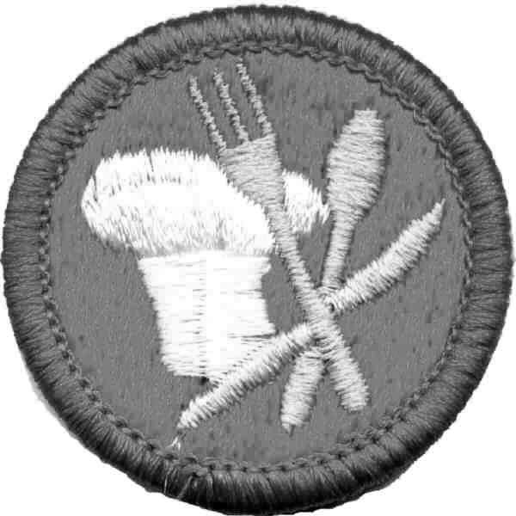Changes Coming for Cooking Merit Badge
Effective January 1, 2014, Cooking Merit Badge will be required for the Eagle Scout rank. Regardless of when a Scout completed the Life rank or began working on Eagle, unless he fulfills all the requirements—with the exception of his board of review—before January 1, 2014, he must earn the Cooking Merit Badge to attain Eagle.
During 2013 the Cooking Merit Badge is undergoing a major revision. The changes to Cooking will first appear in a revised merit badge pamphlet, and the new requirements will then become effective the following January 1, with the release of the Boy Scout Requirements. For example, if the revised pamphlet is released in 2013, the new requirements will become effective on January 1, 2014.
Prairielands Post, Page 8

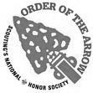Summer Reunion
Come on out to Camp Drake for Summer Reunion. It is going to be a fun day of service, pool party, and lodge meeting. All for $5! It is going to be on August 17th at our lovely Camp Robert Drake. Come join your fellow Arrowmen in a fun service day to get camp ready for the winter.

DUES Due!
DUES! DUES! DUES! Before every OA event, dues will be checked to make sure you can participate. In other words you can’t participate if you don’t pay your dues! SO PAY YOUR DUES! Be eligible to do great activities and buy cool stuff! Another way to pay your dues is to buy a Speed Pass. Ask about it!

Fall Pow Wow
The weekend of Oct. 11 – 13 is the Fall Pow Wow. Come join your fellow arrowmen to do fall chores at Camp Drake and have an afternoon of fun activities. The theme is The Great Gatsby and will feature a fantastic dinner party. The cost is only $20 in advance. Sign up today for a fantastic weekend of fellowship, service, and brotherhood!

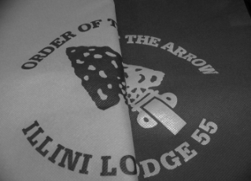
2013 LODGE #55 STRING BAGS ARE IN!
Check out our new Lodge #55 draw string bags. They are AWESOME! Buy one or more for only $5 each – not a bad price! So get them at a lodge event, summer camp or the Scout Shop. Support Illini Lodge!

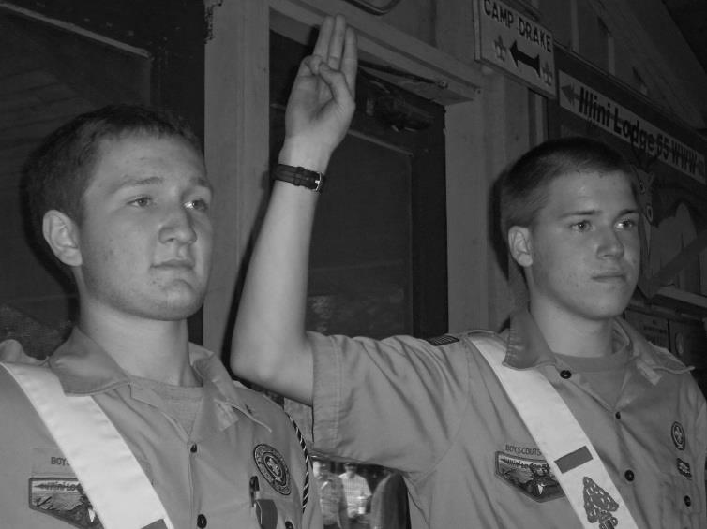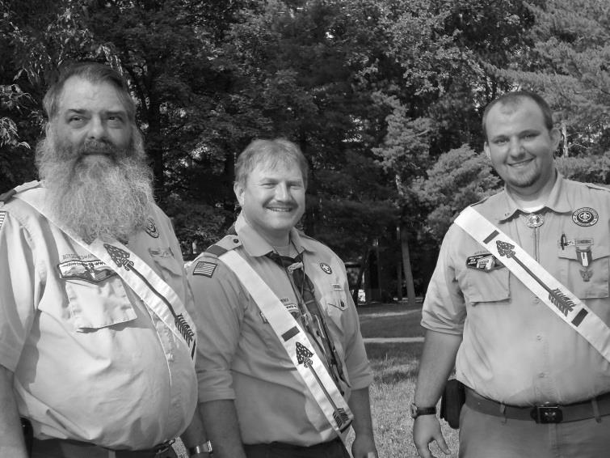
Members of the Order of the Arrow prepare for Call Out Night at Camp Drake. Picture Left: Lodge Chief Owen Meyer and Dom Corso give the Scout sign. Picture Right: Leaders from Troop 35 in Paxton make their way to the arena for the Call Out Ceremony.

