August 2013

Prairielands Council, Boy Scouts of America

Prairielands Post

Serving over 3,000 families in nine counties of east central Illinois and western Indiana
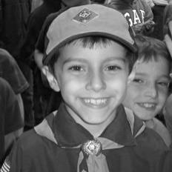
Fall Recruitment Key to Unit Growth and New Leaders
Fall new member recruitment is key to the health of every Cub Scout Pack, Boy Scout Troop and Venture Crew. New members bring new potential leaders, new ideas and new energy to your already successful unit. Last February a special recognition program for unit growth was announced for Cub Scout Packs and Boy Scout Troops. In June 13 Troops in Prairielands Council met the criteria and will receive free cloth rank advancement for the rest of the year. Details of the growth recognition program are included on page 2 of this issue of the Prairielands Post…...make sure you work these goals into your fall recruitment plan.
Prairielands Council will also be unveiling some new recruitment tools for Cub Scouts. These will be reviewed at the District Fall Kick-offs:
Prairie Fire District: Wednesday, August 14, 6:30 pm, LDS Church, 604 Windsor Rd, Champaign
Many Trails District: Thursday, August 15, 6:30 pm, DeCoral Buffet Restaurant, 3355 N. Vermillion; Danville
Each Pack, Troop and Crew are encouraged to have a representative at their District Kick-off. For more information contact your District Commissioner or Senior District Executive.
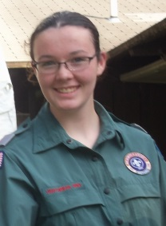

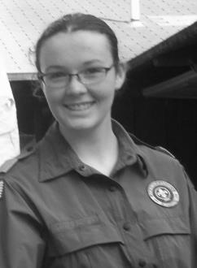
Council News
Fund Your Whole Year Program
In August we’re enjoying the wonderful corn on the cob that Illinois farms offer us……but come October everybody is going to want some Boy Scout Popcorn. Last year Packs, Troops and Crews raised over $200,000 just for their unit programs. This year promises to be even bigger and better. If you missed the Council Kick-off in July, please contact your Senior District Executive to get your Unit Popcorn Kit and all the information you need for a great, great sale. Here are some key dates to plan for….. Monday, September 16, 2013; All Popcorn Show & Deliver Orders Due Saturday, September 28, 2013; Show & Deliver Distribution; Popcorn Sale Begins Monday, October 28, 2013; Show & Deliver Money Due; Take Order & Prize Orders Due Saturday, November 9, 2013; Take Order Popcorn Due Monday, December 9, 2013; Take Order Money Due to Service Centers

Get Your Free Advancements, Free Advancements here!
Troops have an opportunity to earn free cloth rank advancement for their efforts to bring more boys into Scouting. Thirteen Troops earned free rank patches through the end of the year by having more Scouts than last June on June 30, 2013. Troop can earn this to July 2014 by having more registered Boy Scouts on December 31, 2013. The Troop must also recharter on time and participate in the Family Friends of Scouting Campaign to qualify.
Check with your Senior District Executive for more details on this great opportunity.
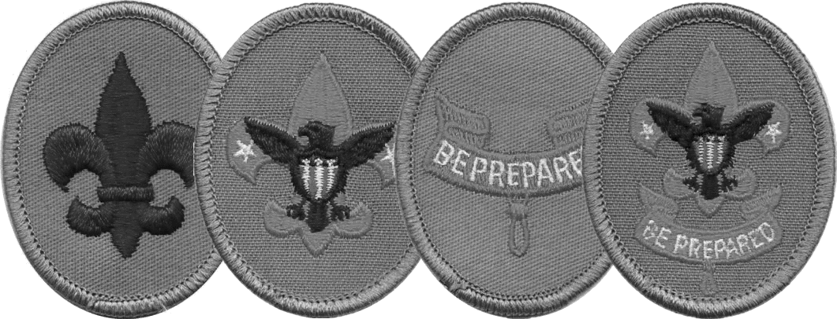

Cub Scout Packs…. Free Pinewood Derby Cars!!!
Pack leaders, don’t forget that your Pack can earn free Pinewood Derby cars for the Cub Scouts in your Pack!
1. Submit your Pack charter in on time
2. Participate in the FOS campaign with a Family Presentation
3. Conduct a spring recruitment rally for new Tiger Cubs
4. Have a fall recruitment for new Cub Scouts
Recognition: A) Free Pinewood Derby Car for each new Cub Scout recruited between April 1 & Oct 31
B) If the Pack has more Cub Scouts on Oct 31 than the end of 2012; free cars for the whole Pack!
Check with your Senior District Executive for more details!
Prairielands Post, Page 2

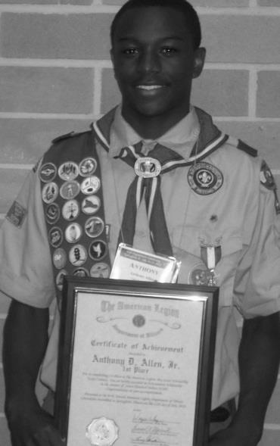
Prairielands Council Eagle Scout Named American Legion Illinois Scout of the Year
Anthony D. Allen Jr., a 2011 Prairielands Council Eagle Scout has been named the American Legion Nominee for the Scout of the Year Award. Anthony, a member of Troop 402, chartered by Canaan Missionary Baptist Church in Urbana received the honor based on his application that epitomized the best of Scouting spirit as evidence by his personal, Scout, School and church honors. With his application Anthony also submitted a 500 word essay titled “Americanism and the Boy Scout Program.”
Anthony was presented the award at the American Legion Illinois State Convention in Springfield on July 12th. As part of the honor Anthony received a $1,000 scholarship. He also read his essay for the American Legion representatives from all across the state, including Marty Zvonar, Vice-Chair American Legion State Committee and Advisory Board Member for Prairielands Council.
Anthony is the son of Anthony Sr. and Penny Allen and he attends Eastern Illinois University in Charleston.

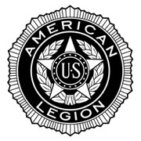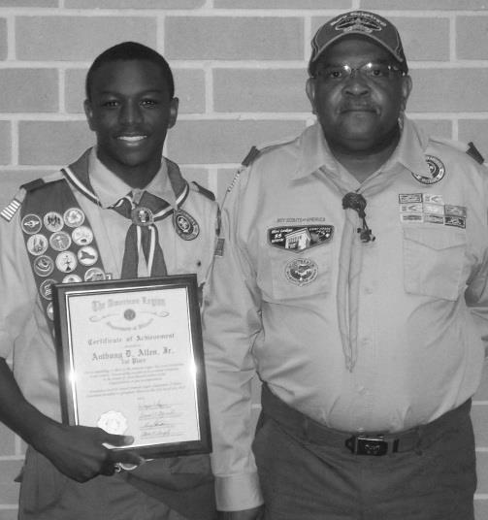
Pictured: Top: Anthony Allen holds his Scout of the Year Award. Bottom: Anthony and Troop 402 Scoutmaster, Marion Knight.

Prairielands Post, Page 3
Council Recognition Event to Honor Volunteers Award Nominations dues Friday, August 30, 2013
The Council Volunteer Recognition Celebration will be held on Sunday, October 20, 2013. The event will be held at the Pollard Forum of Carle Foundation Hospital in Urbana beginning at 3:00 pm. Registration information will be available soon. This event will feature the presentation of a Scouting council’s highest honors for volunteer service. All Scouters are invited to attend this event to help recognize their peers for outstanding service to Scouting and their community. Presentations to be included are: The District Award of Merit The District Award of Merit is the highest award a district can present to an adult volunteer. Recipients must be registered leaders in Scouting, be over 21 years of age and have given service to the district. Nominations are due by Friday, August 30, 2013 with the nomination form available on the council website. Award of Merit honorees will be selected by separate committees of the districts and will be presented by members of the Prairie Fire District and Many Trails District Committees. The Silver Beaver Award The Silver Beaver Award is a national award presented by the local council. It is awarded for noteworthy service of exceptional character to youth by registered Scouters in the jurisdiction of Prairielands Council. The nominee must be a registered member of the Boy Scouts of America and must be at least 21 years of age. The nomination form is posted on the council website; however, please note that the form requires complete and accurate information that may take some Research so it is advisable to being the process as soon as possible. Nominations are due by Friday, August 30, 2013 for committee review, selection and submission to the National Court of Honor for approval. Endowment Awards Also being honored at this event are those people who have supported the council through a gift to the Endowment Fund. New recipients of the James E. West Fellowship, Second Century Club and members of the Council Heritage Society will be recognized. Other awards for significant service will also be presented.
Robeson Scout Shop Ready to Outfit Your New Scouts

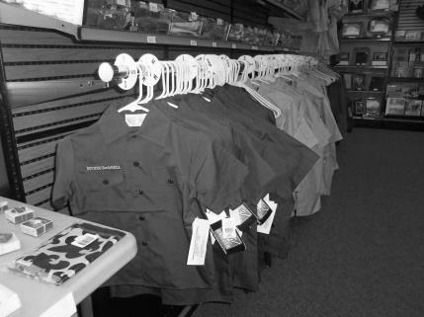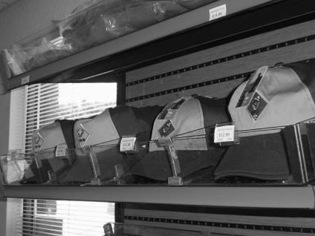
Whether its hats, shirts, belts, neckerchiefs or books, the Robeson Scout Shop is ready to get your new Cub Scouts looking good. New Cub Scouts can’t wait to get into that uniform so make sure their parents know when and where to shop for all their son’s Scouting needs!
Robeson Scout Shop Hours: Monday, Wednesday and Friday; 9:00 am – 6:00 pm Tuesday and Thursday; 12 Noon to 6:00 pm 2nd & 4th Saturdays of the month; 9:00 am – 1:00 pm

Golf Outing for Scouting
Sporting Clays for Scouting
Two Upcoming Events will Benefit Council…..Join in the Fun!
Two special events are quickly approaching that will be both fun and benefit your council. Sporting Clays for Scouting will be held on Saturday, August 24, 2013 and the Rainbow International Golf Outing for Scouting will be on Monday, September 16, 2013.
Sporting Clays for Scouting Is competitive sporting clays held at Olde Farm Sporting Clays located in Oakland, Illinois. It will be held on Saturday, August 24, 2013. This year Prairielands Council is combining the event with neighboring Lincoln Trails Council to determine who has the best marksman in central Illinois. Teams of five compete on the course beginning with registration at 7:00 am and a shotgun start at 8:00 am. Registration fee is $500.00 per team and includes course fees and lunch. Station sponsorships are also available for $100.00. Check out information on the Prairielands Council website or contact Tim Manard at 217-531-0214.

Rainbow International Golf Outing for Scouting will be held on Monday, September 16 beginning with registration and a shotgun start at 12:00 noon at the Urbana Country Club. The outing is sponsored by Rainbow International, a leading home restoration company that specializes in carpet cleaning, water restoration, smoke and fire restoration and mold remediation. Registration for the Golf Outing is $75.00 per person and includes all fees, lunch, dinner and awards. Hole sponsors are also available for $125.00 each. More information will be up soon on the Prairielands Council website or call Tim Manard at 217-531-0214.
Council Cub Scout Camping Weekend
The annual Smiling Pumpkin Outdoor Sports Fest has grown into a fabulous weekend of Cub Scout Camping. Many packs take advantage of the shooting sports event to create an entire weekend of outdoor thrills for members of their pack. In 2012, 10 pack camped in campsites and 1 pack stayed in a cabin. After the overnight fun on Saturday, the Smiling Pumpkin Outdoor Sports Fest from 1:00 to 4:00 pm on Sunday, October 27th provides a wide range of shooting options, as well as games and sports challenges. If your pack plans on camping, please make sure that you have a BALOO trained leader in your unit. To reserve a campsite, please contact Glenn Overby at the Raymond Lee Scout Service Center at 217-531-3010.

Prairielands to Philmont 2014
High Adventure leader Bill Campbell has gained reservation positions for a crew for the 2014 summer at the Philmont Scout ranch in northern New Mexico. For our council contingent, youth and adults will traverse the high mountain back- country for two weeks. Applications are being accepted by contacting the Raymond Lee Scout Service Center. Youth can lock in their position with a $100.00 down payment.

Prairielands Post, Page 4
Labor Day Family Camping at Camp Drake
All Scouts and Scouting family members are invited to enjoy Labor Day Weekend at Camp Robert Drake. Experience a woodland retreat away and get back to nature. Families can enjoy the facilities at Camp Drake at their own pace. Both weekends will be open for tent camping and limited activities for all ages. All of the campsites are available for use, along with a few of the program areas options during the event. The cost for the entire weekend of camping and activities is $20.00 per family or $8.00 per individual for the entire four-day period. Meals are not included and alcohol is not permitted. Campers will be able to use camp facilities at their leisure. Registration is due on the Monday prior to the holiday weekend.

