BOY SCOUTS OF AMERICA
PRAIRIELANDS COUNCIL
SPLASH - O - RAMA

GRAB YOUR SWIMSUIT AND TOWEL and cruise out to CAMP ROBERT DRAKE for a fun day of Aquatics Activities. Plan to make your own SPLASH on SATURDAY, AUGUST 18, from 9:00 am until 5:00 pm. All ages of Scouts and Scouters are welcome to invite guests to attend the SPLASH-O-RAMA and introduce families to the fun at Camp Drake. The safety standards of the BSA will be followed requiring swim checks for abiltiy groups for participants. Please bring your buddy tags from summer camp or other swim skill records to speed up the process for swimming tests. Fee = $10.00 per youth member under 18
EVENTS @ THE POOL
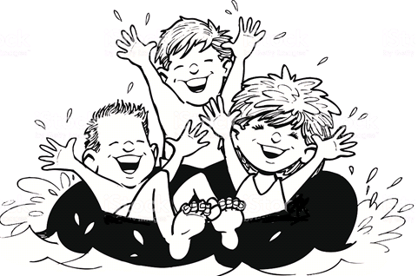
Open pool times with swimmers in the three ability groups will be set up, as well as aquatics games and contests. In age levels, splash contests and swim relays will be held. Plus…Water Polo, Surface Diving, and Cannonball Events.
EVENTS @ THE POND
Boating options will be available throughout the day. Based on swimming ability, participants can canoe, kayak, and rowboats at Poncho Pond. Canoe swamping will be taught.
EVENTS around CAMP
Games will be set up at the Sand Vollyball court area for sport, as well as Sand Castle building. Events at Pebble Beach will feature nature investigation of river life. Plus sprinkler splashes, wading pool fun, and sponge ball targeting

