create the color scheme for the 2016 “Dare to Be Prepared” patch
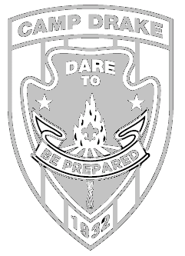
We all know the traditional color of Camp Drake is green…the plateau pines, the tall prairie grass, the water at Poncho Pond…but what other great colors will brighten the patch for the summer of 2016? You can help design the new look, and win a Camp Drake Hoodie for your skill. Use this form to color the 16 emblem
Color the Patch celebrity
In addition to the fabulous hoodie, the winning youth will receive special recognition with a plaque with the actual patch used for the “Dare to Be Prepared” during their week of camp in 2016. The winner will also be immortalized on the web pages of www.campdrake.com for their artistic talents in patch colorization.

This is a youth only contest. Participants must be under 18 years of age on 4/2/16.
Please send entries to Susan Coller @ box 6267, Champaign, IL, 61826-6267 or via e-mail to susan.coller@scouting.org entry must be received before midnight on Thursday, march 31, 2016. winner will be announced as part of the Drake-a-palooza events on Saturday, April 2.

Name of youth ______________________________________ Unit & Number _____________________
City ___________________________________ contact phone number _________________________

