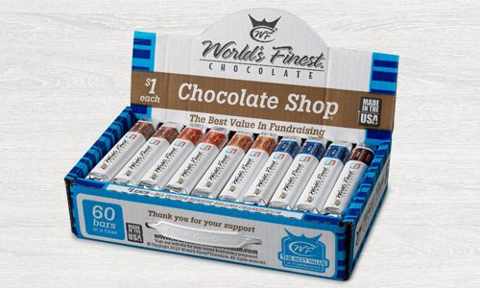

* New Company with top quality chocolate! World’s Finest!
* Delicious variety of $1.00 chocolate bars…..Caramel, Almonds, Crisp, Milk Chocolate & Dark Chocolate
* Still the best way to earn money to attend Camp Drake
* Great profit to help Scouts earn their way to camp *and* support Camp

Drake operations

* Weekly drawings for top sales…fabulous prizes!
* ***NEW!!*** Added value with purchase….free membership to

[www.threewinners.com](http://www.threewinners.com); a coupon website featuring coupons to local restaurants and merchants (See back)

* ***NEW!!*** Localized case boxes with Scouting message for sales

displays and carrying door to door

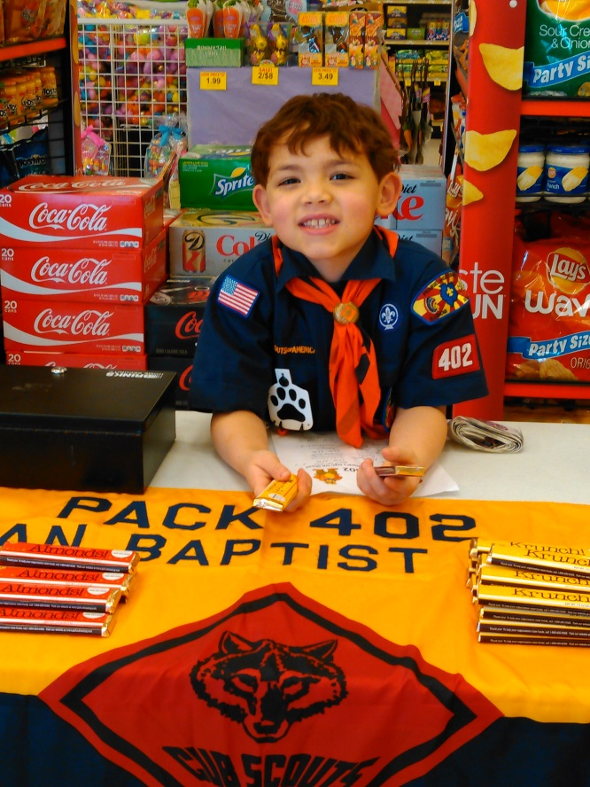

***“Earning your own way” is a valuable life-lesson that Scouts can learn as they prepare to attend summer camp. Participation in the Camp Cash Candy Bar Sale is taken into consideration when reviewing Summer Camp financial assistance requests.***

**Camp Cash Sale Dates**

**Sale begins: Friday, February 26, 2016 Sale Ends: Friday, April 1, 2016**

**More Information Coming Soon!!**