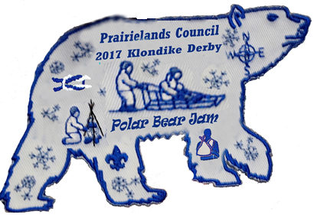
P.B.J.
POLAR BEAR JAM
Prairielands Council Klondike Derby Jan. 28, 2017
9:00 AM till 3:00PM
At Camp Robert Drake
Oh what a great event this shall be!
Polish up on those Scout Skills, test your knowledge of them in Patrol method competition.
Fire Building, First Aid, Compass, Team work skills, Knots, Shoot Slingshots for points and MORE!!!!!
For the First time ever a Saturday Morning Breakfast will be served! Pancakes and Sausage! It is a free will donation style breakfast!
Served from 7:30 AM till 8:30 AM

Lunch this year for the Klondike:
Chili, Cornbread, Grilled Cheese Sandwich.
The O.A. Lodge 55 to have a station promoting the
85th Anniversary year of Camp Robert Drake. This is a place the leaders need to checkout as well.
Each Patrol that completes 6 of the 12 stations when they turn in their score card, will receive a Heat Race ticket.
This ticket will allow that Patrol to race in the GREAT SLED RACE!
So Wax those Sled Runners and practice those Scout Skills
and we will see you there!!!!!

