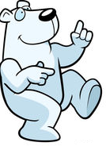
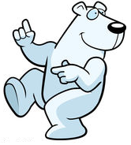
Polar Bear Jam

Gear List for 2017 Klondike
Registration
Regular fee: $14 per scout if paid before January 16th
Late Fee: $20 per scout if paid after January 16th
Cub Scout Fee: $7
Cub Scout Incentive: $7 per Boy Scout per Webelos in their patrol
Call the Scout Office at 217-356-7291 or email susan.coller@scouting.org to register.
All fees are non-refundable.
Campsite reservations
All campsites are on a first come first serve and may be reserved at the Scout Office.
Required material and equipment
Must have all items on these lists to complete all stations!
Patrol Gear
  - Empty Tin Tuna can or like size
  - 3 wooden staves of at least 5’ tall
  - Buffalo Hair (dryer lint)
  - Flint and Steel or Matches
  - Blanket
  - 2 Gallons of water
- Sled
- Tarp (1) 9’ x 10’ in size or close to it. NO 5 x 7
- Rope 3/8” min. Dia. 50’ Min. Length Must be LIKE NEW CONDITION
- Patrol First Aid kit
- Patrol Flag

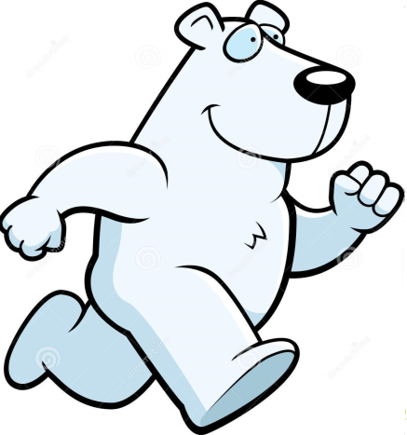

Personal Gear
- Water Bottle
- 6 Ft. of lashing cord (Rope) per Scout on Scout
- Scout Handbook
- Pocket Knife
- Totin’ Chip
- Fireman Chip
- Attire
  - Hat
  - Gloves/mittens
  - Winter coat
  - Appropriate pants
  - Boots or other water proof shoes (no tennis shoes allowed)
  - Rain coat (optional)
Failure to wear proper attire will result in an inability to participate in the event. There will be no exceptions to this rule.
Health and Safety
- Parts A and B of the BSA physical are required for all participants.
- All patrols must be reviewed by Event medical staff before being allowed to participate in the event.
- The First Aid Lodge will be staff for the duration of the event for all medical needs.
- Units camping must provide own first aid after the conclusion of the event.
Rules
- Failure to wear proper attire will result in an inability to participate in the event.
- All patrols must attend their designated lunch period.
- Adult leaders are not allowed to assist patrols in any way.
- If there is no snow on the ground wheels may be used on sleds except during the great sled race.
- All participants must be checked by event medical staff prior to the start of the event.

