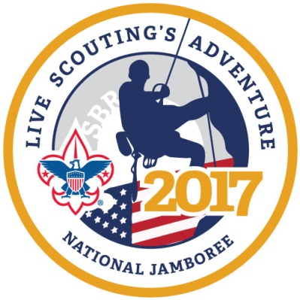
Prairielands Council, Boy Scouts of America
2017 National Jamboree Leader Criteria

Troop Leadership Criteria
Four positions are available: Scoutmaster; 1st Assistant Scoutmaster; 2nd Assistant Scoutmaster; 3rd Assistant Scoutmaster (Youth Leader)

Scoutmaster and the 1st, 2nd & 3rd Assistant Scoutmasters must meet the following:
- Hold current Boy Scouts of America membership in Prairielands Council
- Scoutmaster and 1st Assistant Scoutmaster must be at least 21 years old by the first day of the National Jamboree (July 19, 2017)
- 2nd Assistant Scoutmaster must be at least 18 years of age by the first day of the National Jamboree (July 19, 2017)
- 3rd Assistant Scoutmaster must be at least 18 years of age by the first day of the National Jamboree (July 19, 2017) but not yet 21 years old by the last day of National Jamboree (July 28, 2017)
- Scoutmaster applicants must have experience serving as a Troop Scoutmaster
- 2nd and 3rd Assistant Scoutmasters must have experience serving in a Troop adult leadership role

Crew Leadership Criteria
One or two positions are available: Crew Leader; Asst. Crew Leader. Note: A mixed gender Crew will require one male and one female adult leader.

- Hold current Boy Scouts of America membership in Prairielands Council
- Be at least 21 years of age by the first day of the National Jamboree (July 19, 2017)
- Have experience serving in a Venturing Crew adult leadership role

Important Information for all positions

Commitment & Qualifications
- All leaders and participating Scouts will be expected to sign the Participant Statement of Understanding and Code of Conduct
- Agree to strictly follow all BSA policies and procedures (National & Local) related to the National Jamboree
- Maintain a positive attitude and cooperate with other contingent leaders, Council National Jamboree Committee members and professional staff advisor

Time Commitment
- Participate in individual and group efforts to recruit youth members for the contingent
- Attend monthly Council National Jamboree Committee Meetings
- Time required to complete committee assignments between meetings
- Attend contingent Troop/Crew meetings and functions including Parent’s Meetings, Troop/Crew hikes, social gatherings and Pre-Jamboree Training Weekend
- Attend the full National Jamboree including travel with the contingent

Health & Safety
- Leaders must be in good physical condition and meet the medical and body mass index requirements. (See Part C of the BSA Physical Form for Height/Weight Requirements). The Summit is rugged terrain and the National Jamboree site requires significant walking, often several miles a day.
- File a personal health record (physical form) through the National Jamboree website by April 15, 2017
- Leaders must have completed BSA Youth Protection Training within one year of the last day of the National Jamboree (July 28, 2017) and have completed Leader Specific Training for Boy Scout or Venturing leaders.

Financial Commitment
- Estimated cost for each participate, leaders and Scouts, is $1,975.00.
- All fees must be paid to Prairielands Council per the approved payment schedule
- Leaders are expected to have at least two BSA uniforms

Questions should be directed to Tim Manard, Scout Executive at 217-531-0214 or at tim.manard@scouting.org

