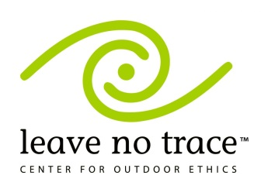 | Leave No Trace Trainer’s Class  September 13-14, 2013  Camp Drake | Tread Lightly Trainer’s Class  September 15, 2013  Camp Drake
Become a Leave No Trace Trainer to run workshops teaching low-impact camping and hiking using LNT principles. This is the required course for Boy Scouts who want the troop LNT Trainer position.  The class is open to adult Scouters plus Scouts and Venturers 14 yr and older (if accompanied by a paid responsible adult).  Registration begins 5:00 pm Friday, Sept. 13; Class begins promptly at 6:30 pm; ends 8:00 pm Saturday.  Fee: $50 includes meals, handouts, and the use of Camp Drake. After August 31, fee is $60. After August 31 the fee is nonrefundable. A minimum of 8 paid registrants is due by August 31 to hold the class. Limited to the first 20 paid registrants.  Some parts of the class will be held outdoors. Dress appropriately. Everyone will need to prepare an 8-12 minute presentation on one of the 7 LNT principles to present that weekend.  Questions contact Ralph Kuchenbrod, ralph@flightstar.com, 217-351-7700 (daytime) |  | Become a Tread Lightly Trainer to run workshops teaching low-impact activities including the use of motorized vehicles.  The class is open to adult Scouters plus Scouts and Venturers 14 yr and older (with a paid adult).  Registration begins 7:30 am and class starts promptly at 8:00 am; ends at 4:00 pm.  Fee: $40 includes lunch, handouts and a Trainer Kit. After August 31, fee is $50. After Aug. 31 the fee is nonrefundable. Registrants after Aug. 31 may not receive the kit at the start of class. This class will be cancelled if the Leave No Trace class is cancelled. If you are also taking the LNT Trainer class the fee is $35(late fee $45). Those taking the LNT Trainer class may camp on Saturday night. Bring your own breakfast for Sunday morning.  Everyone will need to prepare an 8-12 minute presentation on one of the 5 Tread Lightly principles to present that weekend. If you are also taking the LNT trainer class you only have to do one presentation.  Questions contact Ralph Kuchenbrod, ralph@flightstar.com, 217-351-7700 (daytime)
------------------------------------------Cut out and mail in the portion below with payment --------------------------------------------------

Name ____________________________________ If youth, adult with you _____________________________

Address ______________________________ Phone ____________ Email _____________________________

Unit ___________ Scout Position ____________________________ Council ___________________________

Check the class you are registering for:
Leave No Trace Trainer Class $50.00 After August 31 $60.00
Tread Lightly Trainer Class $35(LNT too) or $40.00 After August 31 $45/$50.00
Total Fees: ____________________________________

Send to: Prairielands Council, P.O. Box 6267, Champaign, IL 61826-6267

