Illinois Heartland Commissioner College
November 15, 2014
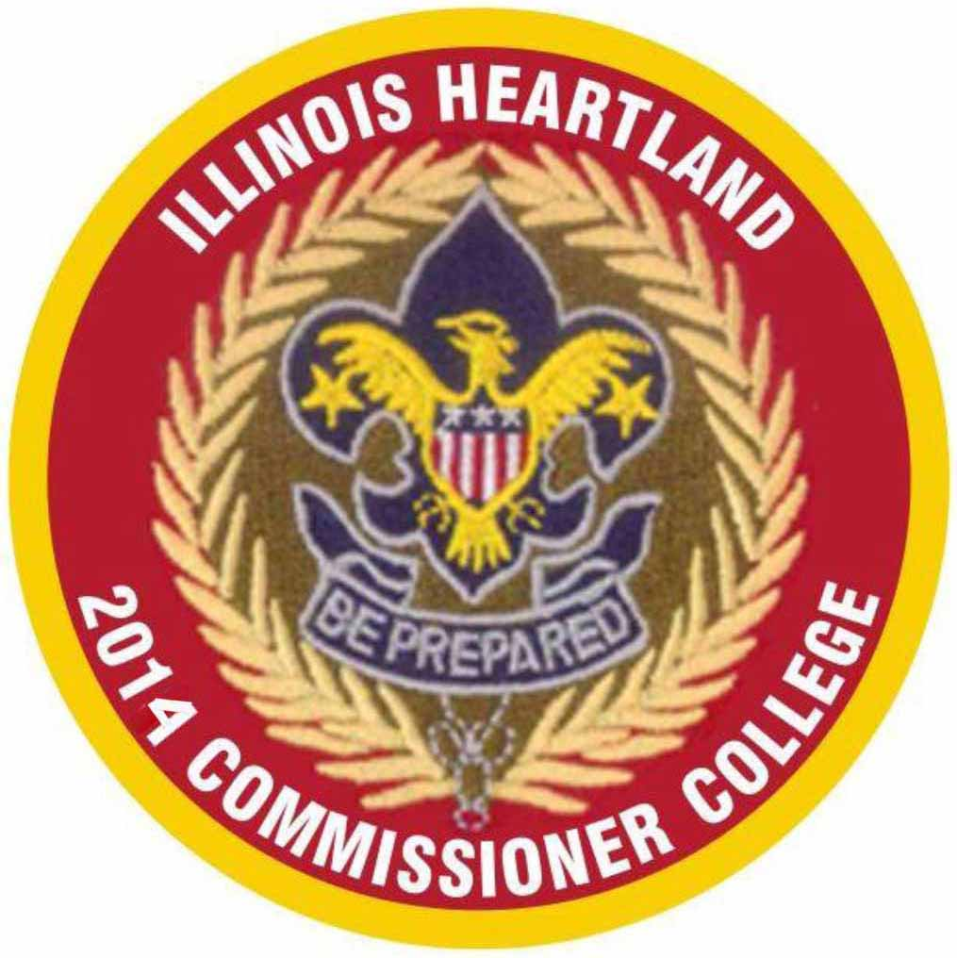
Lincoln Trails Council
In cooperation with
Prairielands Council & W.D. Boyce Council
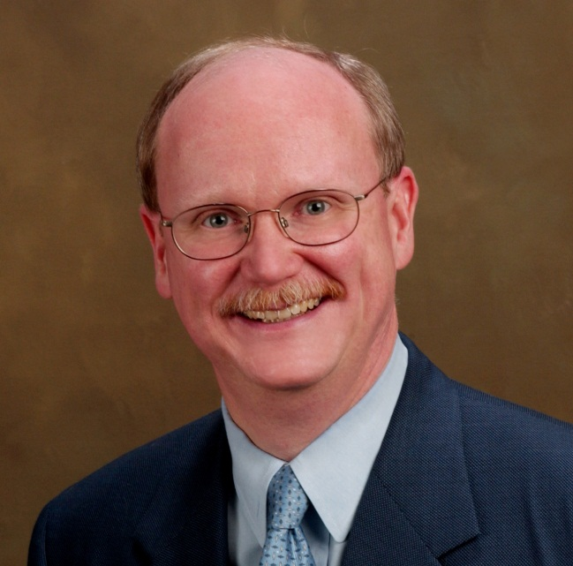
Brian Williams
President, Central Region
Keynote Address Speaker

Lincoln Trails Council
Normal Community High School 262 W. Prairie Ave. Decatur IL. 62523
3900 East Raab Road – Normal, Ill. 61761 P: (217) 429-2326/ F: ((217) 429-3326
Welcome to the Illinois Heartland Commissioner College!
Dress code for the IHCC is a full Class A uniform.
Pre-registration is required. No day-of-event registrations accepted.
How is the IHCC different from other Commissioner College?
The IHCC offers a modified format of course offerings. To start, we encourage Commissioners to complete Orientation and Basic Training in their home councils, where they should also complete and receive their Doctorate Knot in the future. However Commissioner Basic Training will be provided for those who need it. You will receive a Basic Training Certificate and a Continuing Education Certificate for the additional 5 sessions. You can earn Degrees and Continuing Education Certificates based on your personal record per requirement form on the last page (a Scout is Honest). We have slightly modified the BSA sequence of courses. For new Unit Commissioners, we have a suggested track to follow; for experienced Commissioners, we urge you to select those courses that will benefit you most in the position you hold. Everyone is welcome to attend any course that will benefit them the most; our primary goal is to help you become a more effective commissioner, and to help you attain the Doctorate Degree within three years.
Roundtable Commissioners welcome!
Although the IHCC does not offer roundtable-specific classes this year, all commissioner-related topics are relevant to all Roundtable and Assistant Roundtable Commissioners. You can earn the degrees, too!
What will the IHCC offer?
We will offer Commissioner Basic Training. We strongly recommend that all new Commissioners should take orientation to Basic Training within their own councils before attending IHCC. We will also not award Doctorate of Commissioner Science knots; if earned, please arrange for the presentation of this prestigious award in your own council, before your peers.
What is involved in a Bachelor’s Degree?
This is the first set of classes to consider if you do not yet have a Commissioner “degree.” Either follow our suggested track or take the courses that will help you most. This session will contain topics related to unit visitation and helping you fine-tune your skills for guiding units toward a successful program. Bachelor’s topics are primarily 100-level courses, but select those courses that will benefit you most
Who should enroll in the Master’s Degree program?
This program is for those who already hold a Bachelor’s Degree. Topics are more advanced, and build on the Bachelor’s program. Master’s topics are primarily 300-level courses, but select those courses that will benefit you most
Why would one take Doctoral Program and Continuing Education courses?
The Doctoral program is designed is for those who already hold a Master’s Degree. Topics are more advanced, and build on the Master’s program. This training will take a number of years to complete. Continuing Education curriculum is designed to help a Commissioner with a Doctorate Degree (or with a Master’s degree, and Doctorate underway) progress in commissioner studies. Select the courses that will benefit you most in pursuit of your Doctorate degree or in your continuing education.

1
2014 Illinois Heartland Commissioner College
November 15, 2014
Activity and Class Schedule
8:00 – 9:00 a.m. |  |  |  |  | Registration |  |  | Commons Area
9:00 – 9:20 a.m. |  |  |  |  | Opening Session |  |  | Cafeteria
12:00 – 1:25 p.m. |  |  |  |  | Lunch |  |  | Cafeteria
5:00 p.m. |  |  |  |  | Closing & Recognition |  |  | Cafeteria
 | Period |  | 1 | 2 |  | 3 | 4 |  | 5 |  | 6 | 7 | 8
 | Room | 9:30 – 10:10 |  | 10:20 - 11:00 |  | 11:10 – 11:50 | Lunchtime Presentation by – Class Credit! |  | 1:30 – 2:10 | 2:20 – 3:00 |  | 3:10 – 3:50 | 4:00 –4:40
Bachelor’s | 1 | BCS 201-1  Commission-  er  Basic Training |  | BCS 201-2  Commission-  er  Basic Training |  | BCS 201-3  Commission-er  Basic Training |  |  | CED 804  Navigating My Scouting.  org | BCS 107  Unit Journey to Excellence |  | BCS 116  Using Unit Self-Assess Tools | CED 802  Cub Scout Changes  Why Is It Changing
 | 2 | BCS 110  Commission-  er Style |  | BCS 115  Commission-er and Diversity |  | BCS 119  Webelos to Scout Transition |  |  | BCS 130  Commission-er and Advancement | BCS 129  Emphasize Duty to God |  | BCS 112  What Would You Do? | BCS 118  Serve Scouts with Special Needs
Master’s | 3 | BCS 106  Commission-  er Priorities |  | BCS 105  Practical Solutions to Unit Needs |  | CED 801  Bullying |  |  | MCS 306  Counseling Skills | MCS 318  Top 10 Ways Good Service |  | MCS 321  New Unit Service | CED 805  Awards and recognition for Adults
 | 4 | MCS 302  Unit and Council Finance |  | MCS 317  How to Remove a Volunteer |  | MCS 312  Recruiting New Commis-sioner |  |  | MCS 313  Commission-  er Orienting and Training | BCS 104  Unit Visitation |  | MCS 324  Preventing Commission-er Burnout | MCS 309  Need Both Head and Heart
Doctorate/Continuing | 5 | DCS 504  Thesis Project Workshop |  | CED 806  Men & Women – Different Not Better |  | CED 723  Reaching Multicultural Generations |  |  | CED 720  Valuing Diversity Introduction | DCS 601  Doctorial  Projects |  | DCS 605  Being A Project  Advisor | DCS 603  Smart Goals
 | 6 | CED 715  Special Needs Autism |  | CED 714  Special Needs ADHD |  | CED 713  Special Needs Advancement |  |  | DCS 508  Administer Comm. Lifesaving | CED 719  Effective Listening |  | CED 718  Effective Communi-  cation | CED 803  Youth Protection for Youth
Course Notes
• Pre-registration is required. No day-of registrations accepted. Classroom materials will be based on pre-registration numbers.
• IHCC reserves the right to drop a course on the day of the event for any reason. All classes require at least two registrants, with a maximum of 25 per class.
• Course credit for lunchtime keynote address will count toward the degree you are currently pursuing, or may be applied toward a future degree.
• Courses will be 40 minutes long with a 10 minute break between classes. As the discretion of the class and instructor an additional 5 minutes may be used for questions. But the room must be cleared in time for the next class. A 3 minute warning will be given for each class.

2
2014 IHCCS Course Descriptions
BCS 201 - Basic Training Plus
This is the course for new Unit Commissioners. The Morning will keep you in one class room as you get up to speed with your new responsibilities. In the same class room in the afternoon, we are recommending the new Commissioner take CED 804 – Navigating My Scouting.org, BCS 107 – Unit Journey to Excellence, BCS 116 – Using Unit Self-Assessment Tools, CED 802 - Cub Scout changes
BCS 104 – Unit Visitation
Commissioners’ primary role as a friend to the unit is to help the unit succeed. At the core of unit service and the most basic task is the unit visit. This is where the unit can experience the caring and support that the commissioner offers.
BCS 105 – Practical Solutions to Unit Needs
A Commissioner’s primary purpose is to help units succeed, develop a better program, and operate effectively. Frequently Commissioners are called upon to assist units with concerns that could hinder the unit’s success. Participants of this course will become familiar with how to respond to these concerns using Commissioner Helps and Early Warning Signals.
BCS 106 – Commissioner Priorities
Good unit service is created when the commissioner believes that unit service is so critical to the success of Scouting that it takes precedence over all his or her Scouting time.
BCS 107 – Unit Journey to Excellence
Learn about the elements of Unit Journey to Excellence and what it takes to ensure success in every area.
BCS 110 – Commissioner Style
A commissioner’s style—how they provide service—is as important as what they do in the service process.
BCS 112 – What would you do?
This is a group participation/discussion session on some fascinating situations that commissioners might encounter.
BCS 115 – Commissioner and Diversity
Discussion of Scouting as an environment where all differences - age, gender, race, ethnicity, physical ability, personality, and life experiences are valued and integrated into every aspect of the organization’s operations.
BCS 116 – Using Unit Self-Assessment Tools
This course focuses on how to conduct an action planning meeting with a unit using the unit self-assessment tools and the guidelines for the action planning process.
BCS 118 – Serving Scouts with Special Needs
Virtually every unit will experience having a youth who has Special Needs (disabilities). This course will provide Commissioners with knowledge to share with unit leaders so they can provide a program which provides these youth with the Scouting opportunities to succeed.
BCS 119 – Webelos to Scout Transition
The transition of youth from Cub Scouts (Webelos) to Boy Scouts is vital to the health of Scouting. This course will provide Commissioners with knowledge to share with unit leaders so they can assist their units in seamless transitioning of Webelos into Boy Scouts, by giving Webelos Scouts the opportunity to experience the fun and excitement of Boy Scouting.
3

BCS 129 – Emphasizing Duty to God
The purpose of this course is to be informative: to explain how and why Scouting encourages boys to be Reverent. Commissioners can and should coach unit-level Scout Leaders to use existing resources to help boys understand their duty to God, and incorporate it into their lives.
BCS 130 – Commissioner and Advancement
This course describes why and what a Commissioner should know about advancement. A Commissioner should be prepared to assist a unit with basic questions about Advancement and know the District and Council Advancement Chairs and how to contact them when necessary.

MCS 302 - Unit, District, and Council Finance
This class provides an overview of the unit budget plan, who pays for Scouting at all levels from the unit to National, successful unit money-earning projects, and how to help units with special financial needs.
MCS 306 – Counseling Skills
Course covers skills and elements of good counseling
MCS 309 - Good Commissioners Need Both Head and Heart
The objective of this session is to help commissioners with at least one or two years of experience reflect on some of the important qualities of good commissioner service (the “head”). The session also provides a variety of inspirational anecdotes for them to share with unit adults as well as other commissioners (the “heart”).
MCS 312 – Recruiting New Commissioners
Discussion on fielding a complete team of quality Commissioners for quality programs to flourish and district membership to grow.
MCS 313 - Orienting, Training, and Recognizing Commissioners
A session for all administrative commissioners—covers all aspects of commissioner training, including new commissioner orientation, basic training, Arrowhead Honor, the Commissioner’s Key, and continuing education. A variety of classroom techniques are also reviewed.
MCS 317 - How to Remove a Volunteer
As a commissioner, you should be prepared to help guide volunteers with how to remove a volunteer. Note: This session does not address removing a person for cause or grounds for legal action such as theft, misrepresentation, or committing an immoral act. This session will focus on the ineffective volunteer, the person who just isn’t working out.
MCS 318 - Top 10 Ways to Assure Good Commissioner Service
Today everyone has their top 10 list, including commissioners. This session is designed to help experienced commissioners review their priorities and – for some of us – to get back to the basics. This session summarizes key factors in good commissioner service. Most of the key points are covered in depth in other sessions.
MCS 321 - Service to New Units
New units are a tremendous factor in membership growth. New units will enable more young people to grow in character and in personal fitness. The commissioner plays a vital role not only in the creation of new units, but in their continued growth and success

4

MCS 324 - Preventing Commissioner Burnout
Whether we work with a unit or on the Commissioner staff, we have to be ready to face the reality that everyone gets burned out with Scouting at one time or another. This course will look at some ways we can help overcome those burnout situations and motivate ourselves and others toward better tenure in the BSA. This course will look at some ways we can help overcome burnout situations and motivate ourselves and others toward better tenure in the BSA.

DCS 504 - Thesis/Project Workshop
Scouters who have completed their DCS will discuss their challenges and solutions. This course is for those who feel they need more help getting started on or completing their thesis/project.
DCS 508 – Administrating Commissioner Lifesaving
Administrative commissioners are taught to give leadership to a commissioner lifesaving concept. It provides choices in selecting the lifesaving team approach.
DCS 601 – Doctoral Projects
Discussion will include role of projects directed to enhance Commissioner Service, significance of project, approval process, and documentation.
DCS 603 – SMART Goals
Discussion of effective planning milestones in setting of goals.
DCS 605 – Being a Project Advisor
How to work with a Doctoral candidate and keep them on track with a realistic and doable project / thesis.

CED 713 – Special Needs Advancement
Virtually every unit will experience having a youth who has Special Needs (disabilities). This course will provide Commissioners with knowledge to share with unit leaders so they can provide an Advancement program which provides these youth with the Scouting opportunities to succeed.
Participants of this course will become familiar with the “Rules of Engagement” for advancement in each of the Scouting program areas to help them to respond to the needs of these special youth.
CED 714 – Special Needs ADHD
A 2007 AMA study showed that the cumulative incidence of definite ADHD based on DSM-IV criteria was 7.4% by age 19 years. Virtually every unit will experience having a youth who has Special Needs (Attention Deficit/Hyperactivity Disorder (AD/HD)). This course will provide Commissioners with knowledge to share with unit leaders so they can provide a Scouting program which provides these youth with the Scouting opportunities to succeed.
Participants of this course will become familiar with the multiple characteristics common to individuals who have AD/HD and with easy tips to help them to get the most out of the Scouting program.
CED 715 – Special Needs Autism
Virtually every unit will experience having a youth who has Special Needs (Autism Spectrum Disorder). This course will provide Commissioners with knowledge to share with unit leaders so they can provide a Scouting program which provides these youth with the Scouting opportunities to succeed.
Participants of this course will become familiar with the multiple characteristics common to individuals who have Autism Spectrum Disorder and with easy tips to help them to get the most out of the Scouting program.
5

CED 718 – Effective Communication
Good communication begins with good listening, both on the part of the receiver and on the part of the sender. The most effective communication provides what the listeners need in a manner that engages their minds.
CED 719 – Effective Listening
Good Commissioners Hear - Great Commissioners Listen! This session provides participants helpful hints for all to become effective listeners so that true communication may take place.
CED 720 – Valuing Diversity Introduction
The purpose of this course is to increase knowledge and general understanding of diversity issues without making value judgments or calling into question peoples’ religious, culture, or political beliefs and affiliations.
CED 723 – Reaching Multicultural Generation
Reaching the Next Multicultural Generation is most important to carry on the BSA movement. The main objective of the study was to gain a better understanding of the needs and desires of African American, Hispanic/Latino American, and Asian American populations in relation to their participation in youth organizations in general and the Boy Scouts of America in particular.
CED 801 - Bullying
It is not a “phase” youth have to go through. It is not “just messing around,” and is not something youth – bully or target – will “grow out of.” All forms of bullying are prohibited in Scouting. All forms of bullying violate the Scout Oath and Law. Continued bullying of the target will lead to poor self-image, poor self-esteem, quitting Scouting, or becoming a bully to other, younger boys, thus perpetuating the bully cycle.
CED 802 - Cub Scout changes
Focus on mission relation to Oath and Law and role of activities in today’s culture.
CED 803 - Youth Protection for Youth
Get it done before the phone call. Youth need awareness of issues and their role in prevention / stopping.
CED 804 – Navigating My Scouting.org
Tips and tricks on how and what to do with the web site. With concentration on unit visit tracking and web based training.
CED 805 - Awards and Recognition for unit adults and unit commissioners
Awards and Recognition are fundamental concepts in Scouting and are powerful tools when used right. Class will offer discussion of benefits, use, and those available.
CED 806 – Men & Women – Different Not Better
Have you ever felt that you were on a totally different planet than members of the opposite sex? Discover why men and women do things the way they do. This funny, entertaining and enlightening class is guaranteed to give you at least one ah-ha moment when it comes to gender differences.

6

2014 Illinois Heartland Commissioner College Registration

Name:
Address:
Phone:
Email:
Council: District:
Position in Scouting:
Certificate to receive (circle one): Basic Bachelor’s Master’s Doctorate Continuing Ed
Refer to the Progress Record in this manual for requirements.
Course Selection (Please enter course code – e.g., BCS116)
Hour 1: Alternative Selection:
Hour 2: Alternative Selection:
Hour 3: Alternative Selection:
Hour 4: Lunch Speaker – Class Credit!
Hour 5: Alternative Selection:
Hour 6: Alternative Selection:
Hour 7: Alternative Selection:
Hour 8: Alternative Selection:

Cost and Registration:
Participant fee: $25.00
All registrations must be received by 5pm, November 5. No day-of-event registrations accepted.
Register and pay online at: http//Tentaroo.com/LincolnTrails. After you have verified your log in registration at the Lincoln Trails Tentaroo site go to the top and verify or select the IHCC in “Event options” then click on “Profile” at the top and fill in the required information and then “Save Profile”. Then go to the top and, in turn, fill and save the appropriate data under “Your Roster” (your “unit” is your Council or Unit and your “type” is “Troop”) then “Event Registration” and click on “New Leader Registration” again then click on your name then click “Create Registration”. “Profile” will pop up. Click on “Event” box near the center to select IHCC. then click on “Save Leader, Add to Cart”, then click on "Classes" tab and drag over your selected classes, then click on “Save Leader, Add to Cart” again, then click on “Cart” near the top center and fill in the required information to complete your registration and payment.
Fax: Fax this form to: 217-429-3326 Mail a copy of this form with payment to address below.
Mail: Completed form with payment to: Lincoln Trails Council, 262 W. Prairie Ave., Decatur, IL. 62523
7
2014 Illinois Heartland Commissioner
College and Hotel Locations
College Location (“B” on map): Normal Community High School 3900 E. Raab Road, Normal IL 61761
Recommended Hotels (“A” on map): Comfort Suites 310 B Greenbriar Drive 309-452-8588
Complimentary breakfast starts at 6 a.m. on weekends.
Hotel: “IHCC Conference” rate of $89.99/night + tax – if requested by Oct. 15 only!
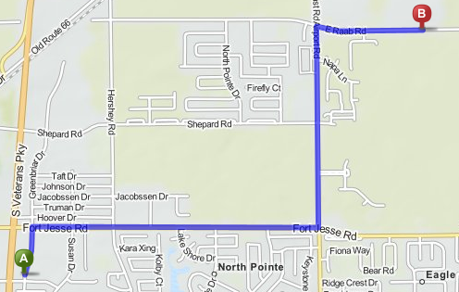
Driving directions to the 2014 Illinois Heartland Commissioner College location:
From the North (via Southbound I-55): Take exit 171 at Towanda. Turn left on CR 29 for 2.2 miles. Turn right on Raab Road. Go 0.6 miles to 3900 Raab Road.
From the East (via Westbound I-74): Take exit 142 at Downs. Turn right onto CR 36 for 0.7 miles. Turn left onto US 150 for 2.0 miles. Turn right onto CR29 for 7.8 miles. Turn left onto Raab Road. Go 0.6 miles to 3900 Raab Road.
From the South (via Northbound I-55): Take exit 157B toward N. Veterans Parkway for 6.1 miles. Turn right onto IL 9 for 2.6 miles. Turn left onto N Towanda Barnes Road for 3.0 miles. Turn left onto Raab Road. Go 0.6 miles to 3900 Raab Road.
From the West (via Eastbound I-74): Take i-55 North toward Chicago for 5 miles. Take Exit 167 onto S. Veterans Parkway toward the airport for 1.2 miles. Turn left onto Fort Jesse Road for 1.5 miles. Turn left onto Airport Road for 1.0 mile. Turn left onto Raab Road; go 0.5 miles to 3009 Raab Road
8
The Commissioner Training Continuum
For many Scouters, Commissioner training has been confusing. We hope to make things a little clearer. Commissioner education should be a cooperative effort between the Commissioners, their local councils and the Commissioner College. Each has a role to play in creating a culture of effective commissioner service.
The Commissioner Training Continuum has 11 steps, and can be completed within five years.
The Starting Point! Each district and council has the responsibility of getting their Commissioners off and running by personally delivering and recognizing this training.
- Fast Start
- Basic Training and Orientation
Your Expertise Grows! Colleges provide learning opportunities so you can better serve units in their delivery of the Scouting program. Advance through courses, increase your knowledge, and earn higher degrees. At the same time, best practices for commissioners will earn you both the Arrowhead Honor and Commissioner’s Key from your local council (and the admiration of your fellow Commissioners!).
- Bachelor’s Degree (7 courses)
- Arrowhead Honor (6 month tenure)
- Master’s Degree (7 courses more)
- Commissioner Key (3 years’ tenure)
Subject Matter Expert! Your dedication to servant leadership has reached a new high. Grow in the esteem of your fellow Scouters and your council as you become a “Commissioner’s Commissioner!” The Doctorate degree is earned at a College; recruiting other leaders and the Doctorate Knot is achieved within your council; your thesis/project and teaching/training can be achieved at either a College or your council.
- Thesis or Project
- Doctorate Degree (10 courses more)
- Teach or Training for one year
- Recruit 3 new Commissioners
- Doctorate Knot (5 years’ continuous tenure)

The IHCC will always include engaging lunchtime speakers whose presentation can be applied for credit toward degrees. This 8-credits-per-year scheme will give dedicated Commissioners the chance to complete all three degrees in a three-year span. Tenure and continuous service is all that’s left to earn your Doctorate Knot!
9
Progress Records for Bachelor’s, Master’s and Doctorate of Commissioner Service
Course Requirements: Courses at all levels should cover subject matter enhancing the knowledge and performance of the Commissioner Service role. Course content should be directed toward Commissioner Service rather than training intended for other program areas. Various training opportunities will exist such as Commissioner Colleges, Universities of Scouting, Philmont Training Center, Commissioner Conferences, President’s Roundtable, or like training venues. Questions should be reviewed with Council Commissioner, assigned Assistant, or College Dean.
Bachelor of Commissioner Science (BCS)
Prerec’s: 1. Current registration as a commissioner.
2. Commissioner Orientation Date: ____________ 3. Commissioner Basic Training Date: _________
Course Requirements: Complete a minimum of seven (7) courses of instruction, reference examples listed in Administration of Commissioner Service #34501 Section III.
Course / date: 1__________________________________
2__________________________________
3__________________________________
4__________________________________
5__________________________________
6__________________________________
7__________________________________
Performance: Approval of Council Commissioner, assigned Assistant Council Commissioner, or College Dean
Signature: _____________________ Date: ____________
Award: Certificate #610624 or equivalent.
Master of Commissioner Science (MCS)
Prerec’s: 1. Completion of bachelor’s degree.
2. Earn Arrowhead Honor. Date: ____________
3. Current registration as a commissioner.
Course Requirements: Complete minimum of seven (7) more courses (total of 14), reference examples listed in Administration of Commissioner Service #34501 Section III.
Course / date: 1__________________________________
2__________________________________
3__________________________________
4__________________________________
5__________________________________
6__________________________________
7__________________________________
Performance: Approval of Council Commissioner, assigned Assistant Council Commissioner, or College Dean.
Signature: _____________________ Date: ____________
Award: Certificate #610623 or equivalent.
Doctor of Commissioner Science (DCS)
Prerec’s: 1.Completion of master’s degree 2. Earn the Commissioner’s Key. Date:_________
3. Current registration as a commissioner.
Course Requirements: Complete a minimum of ten (10) courses of instruction not used to qualify for other college awards (total of 24), reference examples listed in Administration of Commissioner Service #34501 Section III.
Course and date: 1________________________________
2________________________________
3________________________________
4________________________________
5________________________________
6________________________________
7________________________________
8________________________________
9________________________________
10________________________________
Thesis or Project: Complete a thesis or project on a topic of value to Commissioner Service. The topic and final paper / project must be approved by council commissioner, assistant council commissioner, or the dean of a commissioner college doctorate program.
Thesis/Project Title: ______________________________________
Signature: _________________________Date: _____________
Thesis/Project Completion Date: __________________________
Signature: _________________________Date: _____________
Performance: Serve on College of Commissioner Science staff or be training support for commissioners for one year; recruit 3+ new commissioners at any level; approval of Council Commissioner, assigned Assistant Council Commissioner, or College Dean.
Signature: _________________________Date: _____________
Award: Certificate #610622 or equivalent
Doctorate of Commissioner Science Knot
Tenure: Serve as a commissioner for a minimum of 5 years. Service can be in one or more commissioner roles or positions of service. Dates: ______________________________________________
Completion of all above certifies that the individual has met the requirements to earn the Doctorate of Commissioner Science Knot Award, training record is updated, and a presentation at a public event to recognize the individual is held.
10

