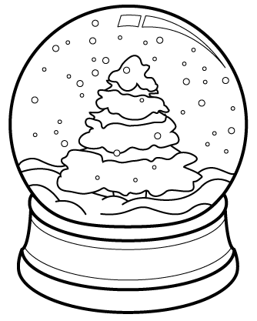
Bold in the Cold

Information for 2016 Prairielands Council Klondike Derby
Registration
Regular fee: $11 per Scout/adult if paid before January 22nd
Late Fee: $15 per Scout/adult if paid after January 22nd
Webelos Fee: FREE!
Cub Scout Incentive: 10 points per Webelos Scout in their patrol (limit 30 points)
Call the Scout Office at 217-356-7291 or email susan.coller@scouting.org to register by 1/22/16. Please let us know number of Klondike youth and adults eating at the event.
All fees are non-refundable.

Campsite reservations
At this time, all campsite assignments are given on a first come first serve basis through the Raymond Lee Scout Service Center.
Health and Safety
- Parts A and B of the BSA physical are required for all participants.
- All patrols must be reviewed by Event medical staff before being allowed to participate in the event.
- The First Aid Lodge will be staffed for the duration of the event for all medical needs.
- Units camping must provide own first aid after the conclusion of the event.
Rules
- Failure to wear proper attire will result in an inability to participate in the event.
- All patrols must attend their designated lunch period.
- Adult leaders are not allowed to assist patrols in any way.
- If there is no snow on the ground wheels may be used on sleds except during the great sled race.
- All participants must be checked by event medical staff prior to the start of the event.
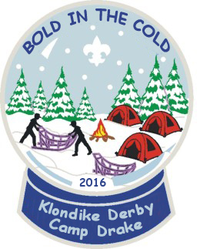
Required material and equipment
  - Patrol Gear
  - 3 wooden staves of at least 5’ tall
  - Buffalo Hair (dryer lent)
  - Flint and Steel
- Sled
- Tarp (2)
- Rope 3/8” min. Dia. 50’ Min. Length
- Patrol First Aid kit
- Patrol Flag
Personal Gear
- Water Bottle
- Scout Handbook
- Pocket Knife
- Totin’ Chip
- Fireman Chip
- Attire
  - Hat
  - Gloves/mittens
  - Winter coat
  - Appropriate pants
  - Boots or other water proof shoes (no tennis shoes allowed)
  - Rain coat (optional)
Failure to wear proper attire will result in an inability to participate in the event. There will be no exceptions to this rule.

