Are You Ready For Spring Fellowship?
The Illini Lodge 55 Trading Post is!
The Illini Lodge Trading Post has some great things for you at Spring Fellowship 2014
SpeedPass
Make your life so much easier by buying a SpeedPass! The current prices for SpeedPasses are as follows:
Have not paid dues or for Fellowship - $55
Paid dues, but not for Fellowship - $45
Paid for Fellowship, but not dues - $35
Paid for dues and Fellowship - $25

Some of the products offered
NEW! Fleeces | $30
NEW! Socks | $10
String bags | $5
Lanyards | $2
T-Shirts | $12
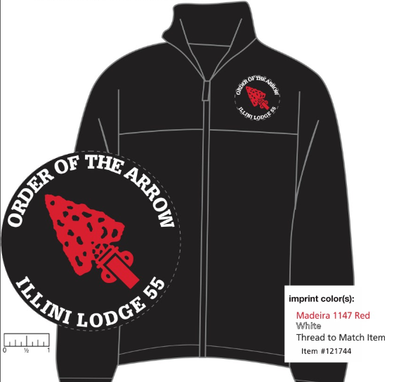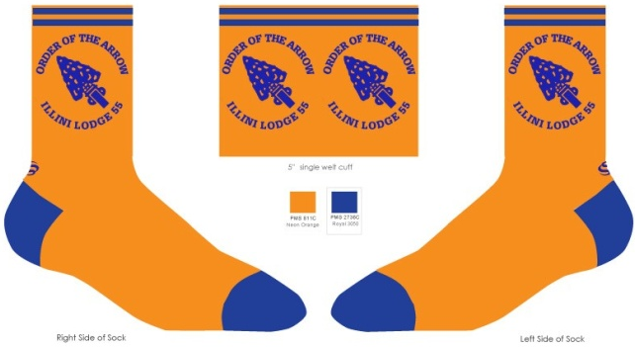

Lodge Math
20 Orange Border Flaps + 20th Anniversary of Illini Lodge = $40
As a special 20th anniversary item we have made only 200 20th anniversary lodge flaps designed by Adam Crutchley and will be ordering no more. 175 of those have a blue border and will be sold at lodge events and summer camp at Camp Drake for $8 each as long as supplies last. 25 have an orange border and we will be selling 20 of those for $40 each and there is a limit of 2 per person. The remaining 5 are for the Lodge Chief to give out at his discretion. We expect to sell out of these orange border flaps quickly, so they will only be available for a short period of time from 1:45pm to 2:15pm at Camp Drake on the Saturday of Spring Fellowship. Make sure you come out and don't miss them! If any supplies remain after Spring Fellowship, we will post additional sales information on the Illini Lodge Facebook page.

Illini Lodge 55 Spring Fellowship MEGA Deals
Mega Deal 1 - Spend $15+ at the Illini Lodge trading post and get a free lanyard
Mega Deal 2 - Spend $25+ at the Illini Lodge trading post and add a drawstring bag for $1 more
Mega Deal 3 - Spend $50+ at the Illini Lodge trading post and get an original lodge flap (red or blue border) free
Mega Deal 4 - Spend $100+ at the Illini Lodge trading post and get a free t-shirt
Purchases of orange border 20th anniversary flaps do not count toward mega deals
Multiple Mega Deals are allowed

