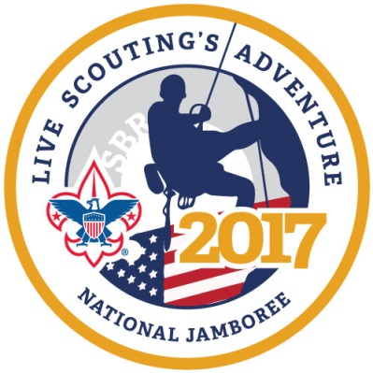
Prairielands Council, Boy Scouts of America
2017 National Jamboree Council Contingent Leader Application

This form is for those interested in applying to serve as a Troop or Crew Leader for the Prairielands Council Troop and/or Crew. The council contingent will be made up of Scouts and/or Venturers from across the Prairielands Council service area.
Individuals interested in serving on the BSA National Jamboree staff should visit www.BSAJamboree.org for more information.
To apply for a Prairielands Council leadership position, please complete this form and submit no later than Friday, August 21, 2015. Applications can be mailed to Prairielands Council, P.O. Box 6267, Champaign, IL 61826-6267 or by email to tim.manard@scouting.org

National Jamboree Council Contingent Leader Application
Positions Available: Please see 2017 National Jamboree Leader Criteria to assure basic qualifications are met
Boy Scout Troop: Scoutmaster; 1st Asst. Scoutmaster; 2nd Asst. Scoutmaster; 3rd Asst. Scoutmaster Venturing Crew: Crew Leader; Asst. Crew Leader

Personal Information:
Name _______________________________________________________________________________
Address ______________________________________City _________________St ____ Zip__________
Best Phone: _____-_____-________ Email: _______________________________________________
Employer ____________________________________________________________________________
Professional Title/Position ______________________________________________________________

2017 National Jamboree Adult Leader Application

Scouting Information
Current Scouting Leadership position ____________________________________________________
Troop/Team/Crew #__________
Other Scouting Leadership positions held during the past 5 years ______________________________
___________________________________________________________________________________
___________________________________________________________________________________
Scouting Leadership Training Courses Completed ___________________________________________
___________________________________________________________________________________
Please attach any additional information or a Scouting resume as needed.
Adult High Adventure experience (check all that apply):
Previous National Jamboree Philmont Trek Northern Tier Canoe Base
Florida Sea Base Troop/Crew High Adventure Trip
Scouting References
_____________________________ Phone_______________ Email___________________________
_____________________________ Phone_______________ Email___________________________
_____________________________Phone_______________ Email___________________________
General Statement Please share why you want to be a National Jamboree Troop/Crew Leader and what special skills and attributes you have that will enhance the experience for our youth members. If necessary please include on a separate paper and attach.
__________________________________________________________________________________
__________________________________________________________________________________
__________________________________________________________________________________

