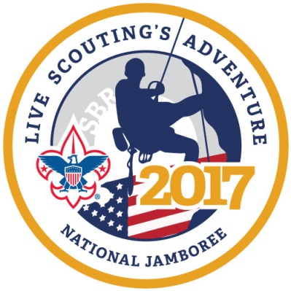
Prairielands Council, Boy Scouts of America
2017 National Jamboree Fact Sheet

Jamboree Highlights

What: The National Jamboree is the Boy Scouts of America’s premiere event held only every four years. The event attracts nearly 40,000 Scouts and adult leaders from around the world.

When: The National Jamboree will be held July 19-28, 2017.

Where: The BSA Summit Bechtel Reserve near Beckley, West Virginia.

Who: Prairielands Council has committed to two Scout groups representing the Council:

Boy Scout Troop: 36 Boy Scouts and four adult leaders
Scouts must be a registered member of a Troop; have earned First Class Rank; be 12 years old before the first day of the Jamboree (July 19, 2017) or be 11 and have completed the 6th grade but not turn 18 before the last day of the Jamboree (July 28, 2017).

Venturing Crew: 8 Venturers and two adult leaders.
Venturers must be a registered member of a Crew and not turn 21 before the last day of the Jamboree (July 28, 2017).

Cost: The estimated cost for the Prairielands Council contingent to the National Jamboree is $1,975 and includes Jamboree participation, transportation, food, pre-Jamboree meetings/events, Council t-shirt, Council Jamboree Shoulder Strips and more.
Those attending will also be responsible for personal expenses such as uniforms, personal gear, souvenirs and spending money.
The council contingent will explore some fund-raising opportunities to assist in the fees. Scouts are also encouraged to participate in the council Popcorn and Candy Bar Sales to raise money

Why: This is a once in a lifetime opportunity for just 45 Boy Scouts and Venturers from Prairielands Council. No Scout should miss their chance to attend a National Jamboree.

Contingent Leadership

Adult leaders for the Council contingent are selected by the Prairielands Council National Jamboree Committee. Candidate applications are reviewed and top candidates interviewed to select the best adult leadership possible for the contingent. Contingent leaders are scheduled to be announced in late August 2015.

2017 National Jamboree Fact Sheet, page 2

Transportation

All leaders and youth member participants are required to travel together in contingent provided Charter Bus.

The National Jamboree Experience

The BSA National Jamboree is the ultimate high adventure opportunity for Scouts. Unlike any other camping experience the Jamboree features mountain biking, zip line, white water rafting, climbing, top quality stage shows and so much, much more. Check out the National Jamboree link on the Prairielands Council website; www.prairielandsbsa.org

To Register

Prairielands Council is only allowed to bring 36 Scouts and 8 Venturers to this big event. The contingent will be filled on a first come, first serve basis. The deadline for registration is January 15, 2016. Once the contingent is full a first come, first serve waiting list will be kept for alternates in the event that a spot comes open.

To register, log on to the council website, www.prairielandsbsa.org and follow the National Jamboree link. A $500 deposit is due to secure a Scout’s registration with the contingent. The balance of payments can be completed following the payment schedule below.

Payment Schedule

Deposit (due with registration): $500.00 A one-time payment in full by January 15, 2016 will
Due January 31, 2016 $295.00 be discounted $100.00
Due March 31, 2016 $295.00
Due June 30, 2016 $295.00
Due September 30, 2016 $295.00
Due November 30, 2016 $295.00
Total $1,975.00

For More Information

For more information contact a member of the Prairielands Council National Jamboree Committee

Rod Henk Phone: 217-474-0207 rhenk@tru-flex.com

Karen Iehl-Morse Phone: 217-840-7702 kiehlmor@Illinois.edu

Tim Manard Phone: 217-531-0214 tim.manard@scouting.org

Or contact Prairielands Council at 217-356-7291 or 1-800-464-7291

