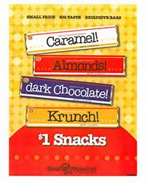
Great American Opportunities
Kathryn Beich Chocolate Bars
Prairielands Council, Boy Scouts of America
Camp Candy Bar Sales Order Form
Unit (Circle One): Pack Troop Crew #_____________
Candy Chair Name:________________________________________________________________
Phone: __________________________________ Cell: ___________________________________
Email: ___________________________________________________________________________
We want to reserve (order by cases):
_____________ Variety x $200 _____________ Caramel x $72
_____________ Almond x $72 _____________ Krunch x $72
_____________ Dark Chocolate x $72 $ ________________ TOTAL
We undersand:
- Variety pack = 4 boxes (Box = 10 krunch, 10 almond, 25 caramel, 5 dark)
- One of a kind pack = 2 boxes (Box = 36 bars)
- Each candy bar sells for $1.00.
- Our unit will earn $.25 for each candy bar sold.
- We will owe Prairielands Council $.75 for each candy bar sold. (Prairielands Council will pay the candy company directly for sold product).
- Candy bar pickup is available throughout the sale. The unit is responsible for any unaccounted candy bars.
- All candy bar sales money is due to the Council Service Center no later than Friday, March 31, 2017.

Sign______________________________________________, Unit Candy Bar Chair

Submit this form at the Raymond Lee Scout Service Center in Champaign or the Danville Scout Office by February 10, 2017.
Questions?
Contact Sharon Kirk
217-531-0218
sharon.kirk@scouting.org

