To: All Unit Leaders
From: Jim Dieker, NYLT Course Director
Re: National Youth Leadership Training
January 19, 2016

Now that the holidays are over, January is half over, and your Unit Charter has been turned in, it's time to look at what's ahead for your 2016 Scouting calendar and program. And that's what brings me to sending you this e-mail.

For the next 7 days, the top Scouts of your Unit will have the opportunity to register for Prairielands Council's National Youth Leadership Training (NYLT) for only $180.00; a $20 discount if paid before January 26th. After January 26th, the cost will increase to $200.00. I would encourage that your Unit Committee consider assisting any Scouts interested in attending NYLT with a training scholarship; the return of leadership skills from your Scout's will be well worth the investment of Unit resources.

Will your Scouts come back to your Unit totally changed after attending NYLT? Maybe; I’ve certainly seen it happen. Will your Scouts come back better leaders to strengthen your Unit's program? ... YOU BET! Over the past year I've had the opportunity to talk to many of the past NYLT participants’ Scout Leaders, and have learn that much of the NYLT leadership skills taught were being applied back home in the Scouting Units.

NYLT is a nationally recognized training experience. Through instruction, followed by games and activities, Scouts learn and develop skills in communication, making presentations, problem solving, team development, and making ethical decisions. Graduates of NYLT become senior leaders in their Units, as well as in their schools, churches, and communities. The Course is led and taught by some of the best Youth Staff in the Council, who are graduates of NYLT. Adult Advisors, who assist the Youth Staff, are Wood Badge trained with extensive experience in training programs. Much of this winter training will happen in the heated Training Center of Camp Robert Drake, and sleeping arrangements will be in heated cabins.

Please consider sending some of your top Scouts to this Mountain-top training adventure who are 14 years of age (or a very mature 13 year old), at least First Class in rank, and want to become great leaders. NYLT applicants must be approved by their Adult Unit Leader.

ALL PARTICIPANTS MUST ATTEND BOTH WEEKENDS of February 26-28th and March 11-13th, 2016 to receive credit for taking NYLT. There are only 32 spaces available and half of these spaces have already been filled. Last year was a fully attended Course; so please don't wait to register your deserving Scouts. Over twenty-one Units from Prairielands Council (as well as a number of units outside of the Council) have sent Scouts to NYLT over the past three years; join the list of Units reaping the benefits of National Youth Leadership Training.

For more information, or should you have questions or concerns that I can answer please contact me at (217)649-8822 or jdieker@sbcglobal.net I've attached a NYLT information and registration form to print off and give to your top Scouts.

Yours in Scouting,
Jim Dieker
NYLT Course Director
Prairielands Council

Prairelands Council’s
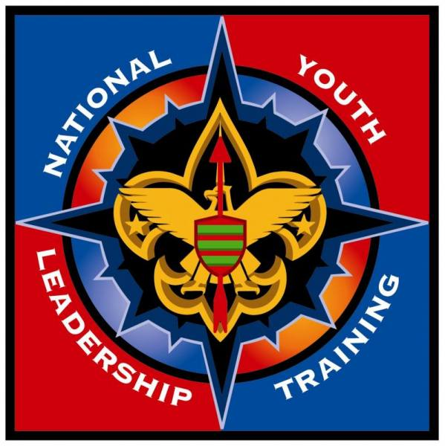

NATIONAL

YOUTH LEADERSHIP

TRAINING

In the cabins of Camp Robert Drake, during the combined
weekends of February 26-28 & March 11-13, 2016!

NYLT is Boy Scouts of America’s premiere youth leadership development program. It is an intensive, FUN, hands-on, and challenging 2-weekend program that combines outdoor adventure and classroom instruction, to provide Scouts with experiences and tools to become great leaders. NYLT focuses on the concepts of what a leader must BE, what a leader must KNOW, and what a leader must DO. Participants learn and develop skills such as communication, problem solving, making presentations, team development, working with adult leaders and youth in administrative areas, and ethical decision-making. Graduates of NYLT become senior leaders in their Troop and Crew, as well as leaders in their schools, churches, and communities.

The course is led and taught by some of the best youth leaders in Prairielands Council, who are graduates of NYLT and typically have staffed other programs. The adult advisors who assist the Youth Staff are Wood Badge trained with extensive experience in training programs.

This 2-weekend course is for mature Boy Scouts and male or female Venturing Scouts who are at least First Class in rank and 14 years of age (or in the eighth grade), who want to become great leaders. Potential participants must be approved by their Scoutmaster/Venturing Advisor, and be in a leadership position or have the potential to do so in their home Troop or Crew. ALL PARTICIPANTS MUST ATTEND BOTH WEEKENDS of February 26-28 and March 11-13, 2016 to receive credit for taking NYLT.

Total course fee is $180, if registration and balance is received by January 26, 2016 ($200 after Jan., 26th). Please contact your Troop or Crew Committee for available training scholarships. For more information, contact Course Director Jim Dieker at 217-359-2246 or jdieker@sbcglobal.net.
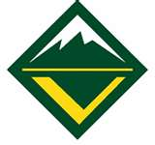
Participant Application for
National Youth Leadership Training
February 26-28 & March 11-13, 2016 at
Camp Robert Drake - Oakwood, Illinois

Send this application with the $180 fee
before January 26, 2016 ($200 after Jan. 26th)
Payable to NYLT, Prairielands Council
3301 Farber Drive, Box 6267, Champaign, IL 61826
Phone: 217-531-3010 or 800-464-7291 glenn.overby@scouting.org

PARTICIPANT INFORMATION (Please Print Clearly)
Scout’s First Name: ______________________________Middle Initial: _______Last Name: _____________________________________
Nickname: _______________________Birth Date:(be 14 or in 8th grade by course) ________________________________________
Address: ________________________________________City: _____________________________________State: ______Zip: _________________
Telephone: _____________________________________E-mail address: _____________________________________________________________
Troop# ________or Crew# ________District: _________________________________Council: _______________________________________
Current Leadership Position: __________________________________________________________________ Gender: Male / Female
Current Rank: _________________________________________ Adult T-shirt size: ______XXL ______XL ______L ______M ______S

CERTIFICATION & APPROVAL SIGNED BY SCOUTMASTER OR CREW ADVISOR
Leader: ________________________________ E-mail: ______________________________________Phone: ________________________________
Address: ________________________________________City: ____________________________________State: ______Zip: __________________
Troop# ______or Crew# ______District: _________________________Council: ________________________________
“I recommend the acceptance of this Scout as a representative of our Unit in the NYLT course. I certify that they meet the age and rank requirements. I further certify that they are serving as, have served as, or have the potential to be our Troop SPL/Crew President. I will do all that I can to help them accomplish their personal leadership goals and to apply leadership skills in our Unit.”
____________________________________________________________________ _____________________________
Signature of Scoutmaster or Crew Advisor Date
______Please contact me to discuss this Scout in more detail.

PARENTAL/GUARDIAN AUTHORIZATION
My child (name) ___________________________ has my permission to participate in the Prairielands Council National Youth Leadership Training. I have read, understand, and agree to the program requirements. I understand that during this program my child will be expected to follow the Scout Oath and Law, participate in the entire program, follow program rules, and that serious violations will result in dismissal from the program. I understand that my child must provide a current and complete BSA Annual Health and Medical Record (Parts A, B, and C) to participate. My child will need the following accommodations for Medical, Physical, Dietary or Religious reasons:
__________________________________________________________________________________________________________________________________________________________________________________________________________________________________
Parent Signature: ______________________________________Print Name: _____________________________________
Daytime Phone #: ____________________________________________Night-time Phone #: _______________________________________
Parent’s E-mail: __________________________________________________________________Date: ______________________________________

