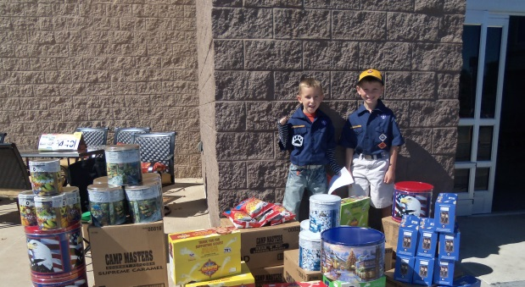
Prairielands Council, Boy Scouts of America
Bringing ALL of the pieces together to GROW your Sale!!
2014 Popcorn Sale Guidebook

2

2014 Popcorn Sale

Welcome to the Popcorn Sale!

This year CAMP MASTERS® Popcorn and Prairielands Council are providing you with all the tools you need to have a great popcorn sale. CAMP MASTERS is committed to providing Scouts, their families and Scouting volunteers with an excellent fundraising program, the best tasting popcorn and the products consumers want. It’s proven!
We hope you’ll use this guidebook as a step-by-step manual to planning, executing and enjoying the rewards of a successful popcorn sale. After all, we know that the most important part of the popcorn sale is what it allows your unit to do!
As always, we look forward to hearing from you. You can always reach us by calling 1-800-624-2060 or emailing campmasters@ramseypopcorn.com. We hope you will explore our website to check out other good tools, downloads and best practices. Together, we can have a great year!

Sincerely,
Wilfred E. Sieg, Jr.
President
CAMP MASTERS Popcorn

4
5
Table of Contents

- Unit Popcorn Kernel Checklist: Page 6

- Unit Program Funding Worksheet: Page 7

- Important Dates and Contacts: Page 8

- Selling Methods: Page 9

- Campmasters.org: Page 10

- Unit Kick-off Planner : Page 11

- Campmaster Kick-off Contest: Page 12

- Council Sales Forms: Page 14

- 2014 Products: Page 15

- Sales Incentives & Prizes: Page 16

- High Achiever Incentives: Page 17

- Additional Incentive Information: Page 18

- Distribution Information: Page 19

- Mystery Houses: Page 20

6
Unit Popcorn Kernel Checklist

Attend and participate in the Council Popcorn Kick-off, July 24, 2014.

Use the Fund Your Adventure worksheet to plan your year, make a budget and set goals (download from campmasters.org).

Formulate a popcorn sales plan that includes the three methods of selling popcorn: Order Form, Show and Sell and Online.

Create a timeline of when all order forms, popcorn monies and Scout prize forms will be due. Be sure to consider the key dates on page 10.

Hold a unit kick-off meeting for parents to inform and motivate them to help with your unit’s sale.

Prepare hand-outs for your unit kick-off meeting for both leaders and Scouts. Hand-outs include:
• Family Guide with prize brochure and order form
• Key Dates
• Goals for the unit and for the family
• A parent job description or list of expectations

Promote corporate popcorn sales with your parents. They can take an order form to work and help boost their son’s sales.

Complete the unit product order form and submit online. Keep photocopies of your Scouts’ take order forms so they can be used the following year.

Complete and submit the following forms to the Council Service Center:

Coordinate your unit’s popcorn pick-up and distribution.

Distribute prizes upon receipt in a timely manner.

Celebrate your unit’s success and use the money raised to provide awesome program opportunities for the Scouts to enjoy!

7
Unit Program Funding Worksheet

SEPTEMBER |  | OCTOBER |  | NOVEMBER
Planned Activity | Cost | Planned Activity | Cost | Planned Activity | Cost
This Month's Total: | $0.00 | This Month's Total: | $0.00 | This Month's Total: | $0.00
DECEMBER |  | JANUARY |  | FEBRUARY
Planned Activity | Cost | Planned Activity | Cost | Planned Activity | Cost
This Month's Total: | $0.00 | This Month's Total: | $0.00 | This Month's Total: | $0.00
MARCH |  | APRIL |  | MAY
Planned Activity | Cost | Planned Activity | Cost | Planned Activity | Cost
This Month's Total: | $0.00 | This Month's Total: | $0.00 | This Month's Total: | $0.00
JUNE |  | JULY |  | AUGUST
Planned Activity | Cost | Planned Activity | Cost | Planned Activity | Cost
This Month's Total: | $0.00 | This Month's Total: | $0.00 | This Month's Total: | $0.00
Registration & Insurance | $0 |  | Number of Selling Scouts in your Unit: |  | 40
Advancements | $0 |  | Your Unit's Commission |  | 30%
Uniforms | $0 | Enter the number of Scouts and your commission to calculate your goals: | Unit Total Activity Cost and Expenses |  | $0.00
Scholarships | $0
Other Expenses | $0 |  | Unit Sales Goal |  | $0.00
Annual Total: | $0
 |  |  | Scout Sales Goal |  | $0.00
11
Unit Kickoff Planner
A great sale starts with a great kickoff! Follow these simple steps to start your popcorn sale with a BANG and motivate Scouts, parents and other volunteers.

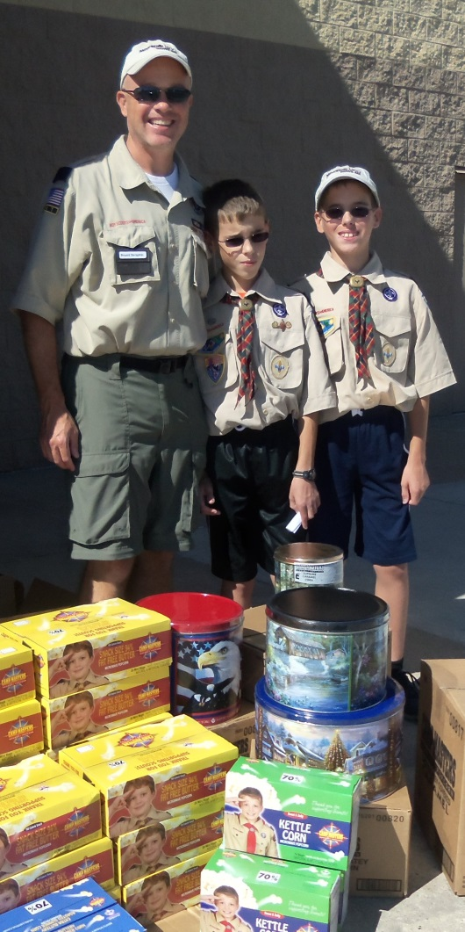
1. Plan ahead. Think of an agenda that will be fast-paced and FUN! A good kickoff should be under an hour.

2. Emphasize WHY it is important to sell popcorn.
Communicate the exciting Scouting program and how families can cover all their annual expense with one sale. CAMP MASTERS makes it easy to sell delicious popcorn so Scouts can spend more time having fun and less time selling popcorn.

3. Show Scouts the tools available from CAMP MASTERS. This includes their order forms, prize sheets, training videos and much more! Visit campmasters.org to see all the tools available.

4. Spend some time explaining the different ways to sell, key dates for the program and show and sell locations.

5. Motivate Scouts to set goals for their sales and to pick an awesome prize! CAMP MASTERS offers great high achiever incentives for top sellers.

6. Finish the evening with a memorable event, like throwing pies in the leaders’ faces or funny role-playing. A kick off will be exciting when Scouts are involved in the action!

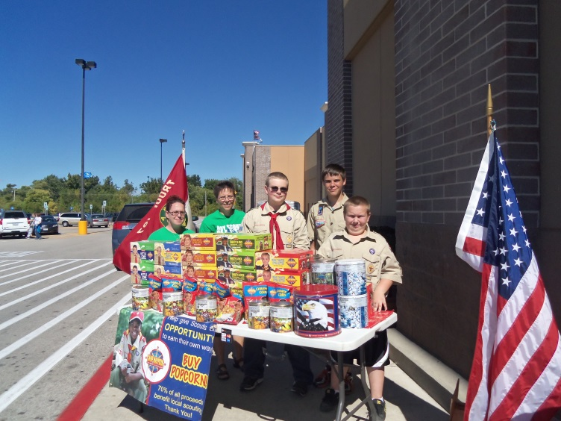

14
Council Sales Forms
Your council has partnered with CAMP MASTERS to offer you the best popcorn sale program. Here are a few of the forms coming from your Council to support the sale.
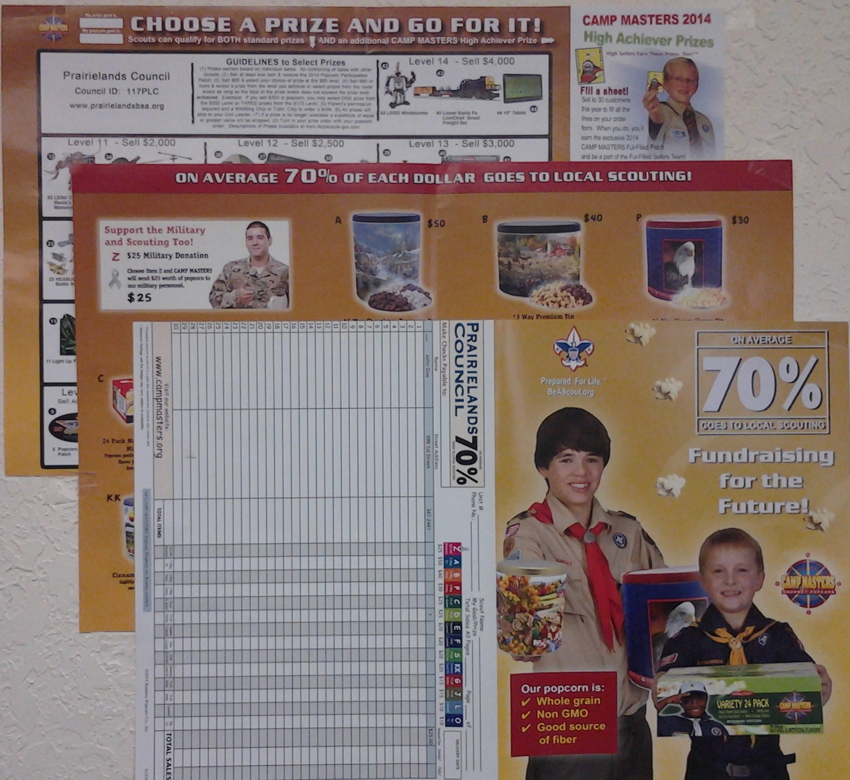

10
Campmasters.org
Campmasters.org is the best place to visit for the latest popcorn sale tips, tricks and tools. You will find lots of great downloads and training videos to help support your sale.

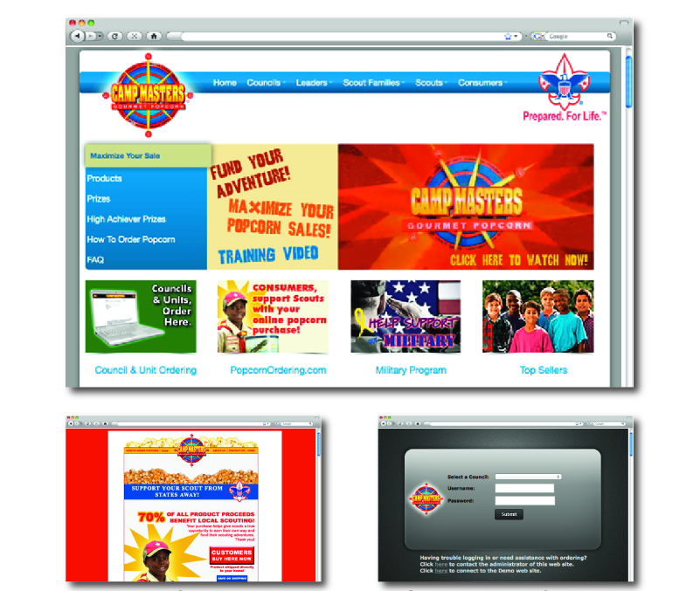
Council and Unit Ordering
Camp MASTERS is proud to offer their new online sale management tool and great customer service. Access Council and Unit Ordering interface at campmasters.org
Popcorn Ordering.com
Customers can support Scouts from faraway with PopcornOrdering.com. Your Scouts can sell online to help earn their own way and fund their Scouting adventures!
15
2014 Products

24 oz Popping Corn Original Popping Corn in decorative tin. |  | $10.00
8 oz Caramel Corn Gourmet caramel corn kept fresh in a decorative collectible tin. |  | $10.00
14 Pack Kettle Corn Microwave A sweet and salty old fashion kettle corn taste. |  | $15.00
15 Pack Extra Butter Roasted Summer Corn Microwave Popcorn. |  | $15.00
Cinnamon Crunch Popcorn Tin Lightly sweet popcorn with warn, savory, cinnamon. |  | $20.00
20 Pack Snack Size 94% Microwave Great flavor AND portion control. |  | $20.00
20 oz Chocolate Covered Caramel Corn Delicious caramel corn covered with rich chocolate in a decorative tin |  | $20.00
20 oz Supreme Caramel w/Almonds, Pecans & Cashews Caramel corn with whole & crushed almonds pecans and cashews in a decorative tin |  | $20.00
24 Pack Variety Microwave Popcorn A variety pack that bursting with flavor |  | $25.00
24 Pack Movie Theater Extra Butter Microwave Popcorn perfectly with Extra Buttery Flavor just like the movie theaters. |  | $25.00
$25.00 Military Donation Campmasters will send $25.00 worth of popcorn to U.S. Military personal. Available in Take Order Sale Only |  | $25.00
3-Way Cheesy Cheese Tin Collectable tin; 3 BIG BAGS! White Cheddar Cheese, Yellow Cheddar Cheese, and Cheesy Salsa Popcorn |  | $30.00
3-Way Premium Tin Chocolate Caramel, Butter Toffee, Supreme Caramel with Almonds, Pecans and Cashews |  | $40.00
5-Way Chocolatey Treasures Tin Chocolatey Peanut Brittle, Chocolatey Caramel Corn, White Frosted Caramel Corn, White Frosted Pretzels and Chocolatey Pretzels. YUM! |  | $50.00

16
Sales Incentives & Prizes
Pick a prize and set a goal! Scouts can earn great prizes from the Prize Program in addition to supporting the unit’s activities.

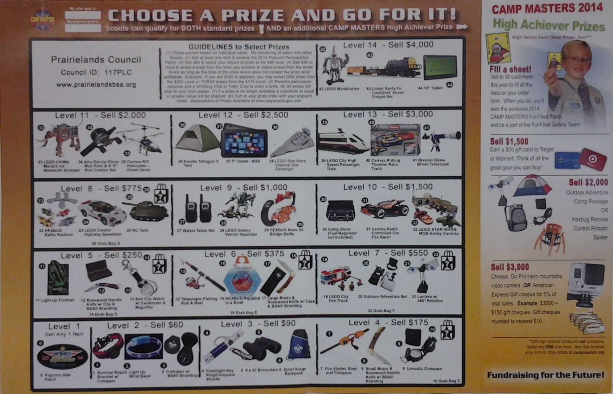
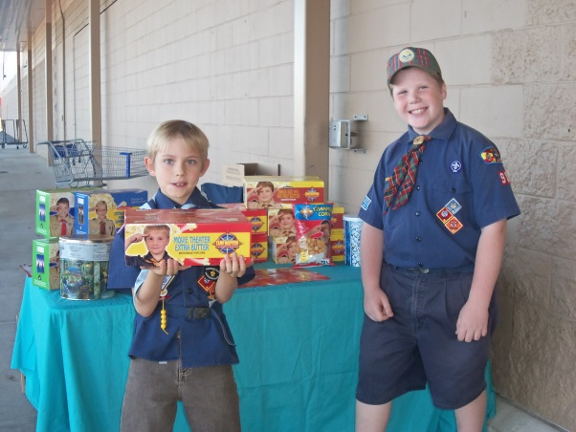
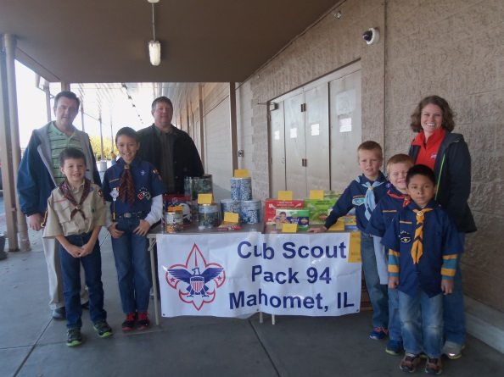

17
High Achiever Incentives
Encourage Scouts to set goals and earn great rewards IN ADDITION to their prize program incentives. CAMP MASTERS offers High Achiever Prizes to top sellers.

8
Important Dates
DATE | ITEM
Thursday, July 24, 2014 | Council Popcorn Kick-off, Camp Robert Drake
Saturday, September 13, 2014 | Show & Deliver Orders due to the Council Service Center by 12 Noon
Saturday, September 27, 2014 | Show & Deliver Popcorn Distribution; Champaign
 | POPCORN SALE BEGINS
Friday, October 31, 2014 | All Show & Deliver Sales Money Due to Council Service Center
 | All Show & Deliver Returned Product Due to the Council Service Center
 | All Take Orders Due to the Council Service Center
 | All Prize Orders Due to the Council Service Center
Saturday, November 15, 2014 | Take Order Distribution; Champaign, Danville and Watseka
Friday, December 12, 2014 | Final Popcorn Money Due to Council Service Center
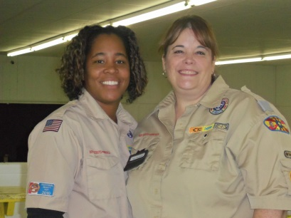
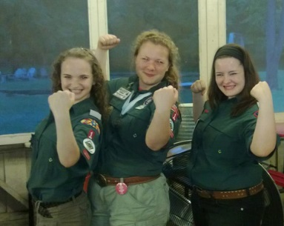
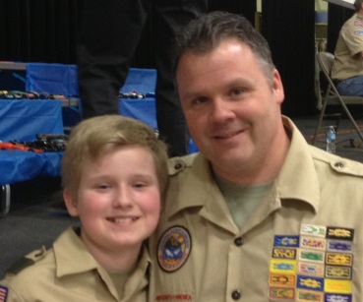

Council Contacts
Council Staff Advisor | Elliot Smith | 217-531-3011 | elliot.smith@scouting.org
Support Staff Contact | Gloria Marsh | 217-531-0213 | gloria.marsh@scouting.org
 | Sharon Kirk | 217-531-0218 | sharon.kirk@scouting.org
District Staff Contact
Prairie Fire District | Lovetta Ash-Simpson | 217-531-0217 | lovetta.ash-simpson@scouting.org
Many Trails District | Mike Graham | 217-531-0212 | mike.graham@scouting.org

9
Selling Methods

Scouts can sell well and safely by following these proven methods and tips.

Sell 3 Ways!

1. Sell with your Order Form! Scouts can use this script to help build their confidence and salesmanship!

“Sir/Ma’am, hello my name is ___________, I am a Scout with Pack/Troop _______ here in __________. We are selling popcorn to raise money for our unit to attend camp. You can help us by trying some of our DELICIOUS popcorn. You will help us won’t you?”

2. Try Show and Sell! Arrange Show and Sell locations so your Scouts can be seen in front of high visibility storefronts or community gatherings. Be sure to plan in advance and communicate dates/locations!

3. Sell online! It’s easier than ever and you can help Scouts sign in at campmasters.org
or PopcornOrdering.com.

POPCORN SAFETY TIPS
• Always sell with an adult or buddy
• Never enter a stranger’s house
• Keep checks and cash in a separate envelope with your name on it
• Always walk on the sidewalk whenever possible
• Never sell at night
• Wear your uniform
• Always be courteous!

POPCORN SALES TIPS
Ten ways to make a popcorn sale.
• Ask your parents.
• Ask your relatives.
• Knock on your neighbor’s door.
• How about your parents’ friends?
• Sell at your place of worship.
• Ask your parents to take an order form to work.
• Have “Super Sale Day” with your fellow Scouts.
• Sell Door-to-Door around your community
• Popcorn makes great holiday gifts!
• Visit businesses around your town for a corporate sale.

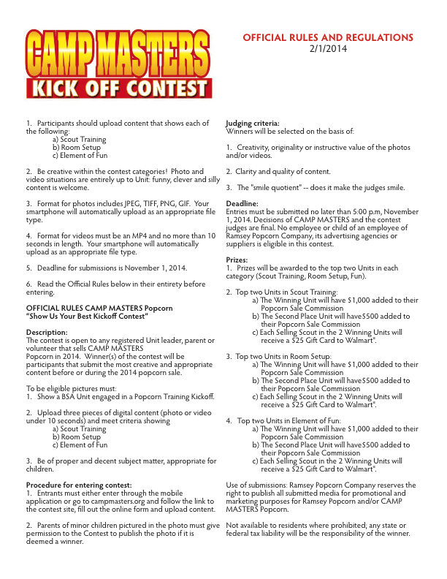

19
Distribution Information
Moving Your Popcorn from
Distribution Site to Unit Storage

Part of the Popcorn Sale experience is trying to see how many cases of Popcorn can be squeezed into Ford Focus. Here is a little guideline as to what kind of vehicle…...or vehicles you will need when you pick up your popcorn.
Up to 20 Cases of Popcorn Mid-Size Car
20-40 Cases of Popcorn Jeep or Crossover
40-60 Cases of Popcorn Mini-Van
60-70 Cases of Popcorn Suburban/Explorer
Over 70 Cases of Popcorn Truck or U-Haul

Picking Up Your Popcorn
Units can sign up at any time for time slots for Popcorn pick-up both for Show & Deliver (Saturday, September 27) or Take Order product (Saturday, November 15). To reserve your time slot contact Gloria Marsh at 217-531-0213. Please note that Gloria’s hours are Monday through Friday, 9:00 am to 1:00 pm.
Show & Deliver Product Pick up
Saturday, September 27

Knox Warehouse
1305 N. McKinley Ave, Champaign
(Directly behind Arrowhead Bowling Alley)

Take Order Product Pick up Saturday, November 15
Champaign: Knox Warehouse
1305 N. McKinley Ave., Champaign
(Directly behind Arrowhead Bowling Alley)

Danville:
Faulstich Printing Company
2001 E. Voorhees, Danville

Watseka:
Fred’s Woodworking
307 W. Mulberry, Watseka

Probably Not!!!

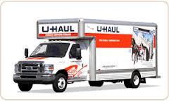

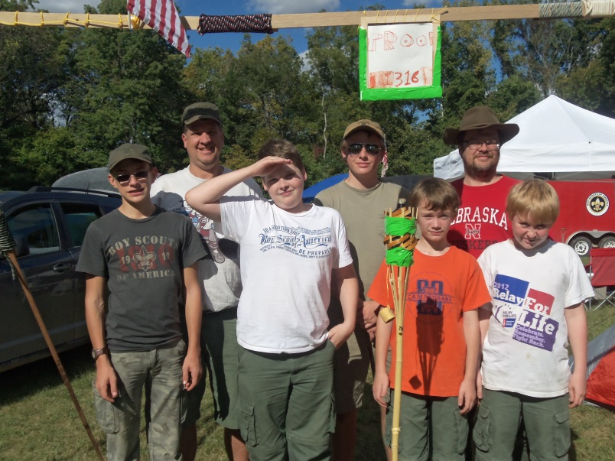

Mystery Houses are BACK!!
Going door to door may just result in instant profit for 25 lucky Scouts! Scatter throughout the council will be 25 Mystery Houses. The first Scout to knock on the door of a Mystery House and pitch some popcorn will instantly receive a $10 Gift Card from Walmart from the home owner. Mystery Houses are planned for Arcola, Champaign, Chebanse, Covington, Danville, Georgetown, Hoopeston, Mahomet, Monticello, Rantoul, St. Joseph, Tuscola, Urbana, Watseka and Westville.

Beginning October 4, check the Council Facebook page, Prairielands Council, Boy Scouts of America, for hints to help locate Mystery Houses.
Probably Not!!!
Probably Not!!!
Probably Not!!!
Additional Incentives Information
Cash Option
Unit receives 36% commission of all sales to distribute between the unit and individual Scouts.
Prize Option
Unit receives 33% commission of all sales plus prizes for individual Scout sales

Mystery Houses are BACK!!
Going door to door may just result in instant profit for 25 lucky Scouts! Scatter throughout the council will be 25 Mystery Houses. The first Scout to knock on the door of a Mystery House and pitch some popcorn will instantly receive a $10 Gift Card from Walmart from the home owner. Mystery Houses are planned for Arcola, Champaign, Chebanse, Covington, Danville, Georgetown, Hoopeston, Mahomet, Monticello, Rantoul, St. Joseph, Tuscola, Urbana, Watseka and Westville.

Beginning October 4, check the Council Facebook page, Prairielands Council, Boy Scouts of America, for hints to help locate Mystery Houses.
Probably Not!!!

Guideline to Selecting Prizes
- Prizes earned are based on individual sales. No combining of sales with other Scouts.
- Any Scout that sells at least one item will receive the 2014 Popcorn Participation Patch.
- Scouts that sell $60 selects his choice of prize from the $60 level.
- Scouts that sell $90 or more can select from the level achieved or select prizes from the lower levels as long as the total of the prize levels does not exceed the prize level achieved. Example: If a Scout sells $550 in popcorn he may select ONE prize from the $550 level or THREE prizes from the $175 level.
- Parents permission and a Whittling Chip or Totin’ Chip required to order a knife.
- All prizes will be shipped to the Unit Leader/Popcorn Kernel.
- If a prize is no longer available a substitute of equal or greater value will be shipped.
- Unit Prize Orders are due to the Council Service Center on Friday, October 31, 2014. Description of prizes available at www.boyscouts-gcc.com
Mystery Houses are BACK!!
Going door to door may just result in instant profit for 25 lucky Scouts! Scatter throughout the council will be 25 Mystery Houses. The first Scout to knock on the door of a Mystery House and pitch some popcorn will instantly receive a $10 Gift Card from Walmart from the home owner. Mystery Houses are planned for Arcola, Champaign, Chebanse, Covington, Danville, Georgetown, Hoopeston, Mahomet, Monticello, Rantoul, St. Joseph, Tuscola, Urbana, Watseka and Westville.

Beginning October 4, check the Council Facebook page, Prairielands Council, Boy Scouts of America, for hints to help locate Mystery Houses.

High Achievers Prizes
Fill A Sheet: Scouts that sell to 30 customers to fill all the lines on the order form will earn the exclusive Ful-Filled Patch
Sell $1,500: Earn a $50 gift card to Target or Walmart.
Sell $2,000: Earn the Outdoor Adventure Camp Package or Hexburg Remote Control Robotic Spider
Sell $3,000: Choose the GO PRO HERO mountable video camera OR American Express Gift cheques for 5% of total sale.

F

$800 Earns a Big Prize
In addition to their regular prize selection, Scouts than sell $800 in popcorn will receive a Skylight Rocket!!!

Prairielands Council $1,000 and Over Club
Once again Prairielands Council will host a special event for Scouts selling $1,000 and over. Still in the planning stage, the event will be a University of Illinois sporting event free to the salesmen and with special pricing for family members. A recognition event will be held at a nearby location before or after the event…...watch for more details!!
Mystery Houses are BACK!!
Going door to door may just result in instant profit for 25 lucky Scouts! Scatter throughout the council will be 25 Mystery Houses. The first Scout to knock on the door of a Mystery House and pitch some popcorn will instantly receive a $10 Gift Card from Walmart from the home owner. Mystery Houses are planned for Arcola, Champaign, Chebanse, Covington, Danville, Georgetown, Hoopeston, Mahomet, Monticello, Rantoul, St. Joseph, Tuscola, Urbana, Watseka and Westville.

Beginning October 4, check the Council Facebook page, Prairielands Council, Boy Scouts of America, for hints to help locate Mystery Houses.
Please note that no member of the Council Staff will serve as a Popcorn Mystery House.
Arcola
Arthur
Champaign (5)
Chebanse
Covington
Danville (4)
Georgetown
St. Joseph
Tolono
Tuscola
Urbana (3)
Veedersburg
Watseka
Westville
Gibson City
Hoopeston
Mahomet
Monticello
Paxton
Rantoul
Savoy

……..Don’t forget the Mystery Houses
Going door to door just might result in instant profit for 30 lucky Scouts. Scattered throughout the council will be 30 Mystery Houses. The first Scout to knock on the door of a Mystery House and pitch some popcorn will instantly receive a $10 Walmart Gift Card from the homeowner.
Mystery Houses are planned for

Have a great sale!
Council programs

